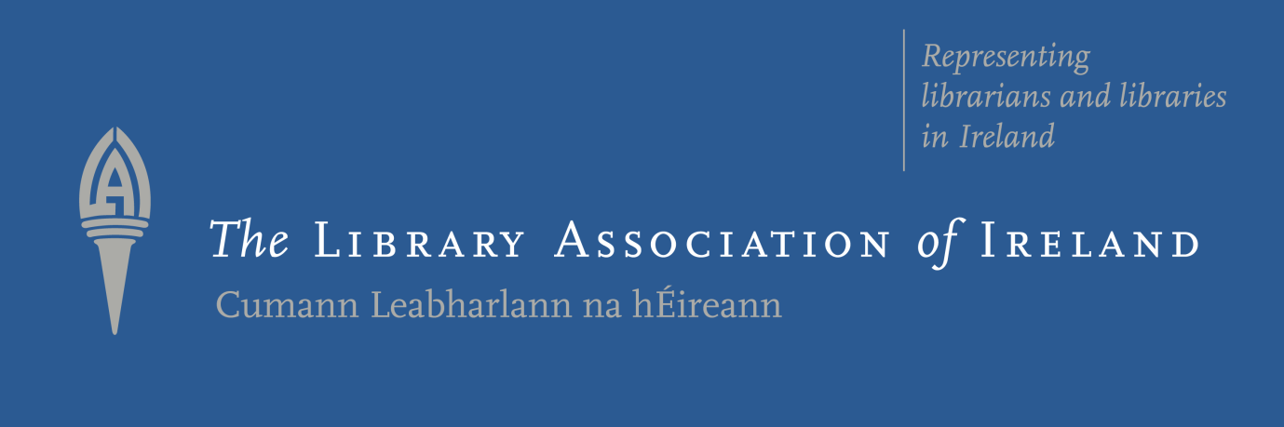

Library Association of Ireland
Public Libraries Section Project Prize 2019
The Library Association of Ireland presents the Public Libraries Section Project Prize 2019. Please read all details below and send your entry on the attached application form.
Best of luck!
Evaluation Criteria
Applications should consider the objectives and goals of the competition:
- To give individuals an opportunity to develop an idea they may have and wish to implement in their library branch
- To stimulate ideas and creativity amongst public library staff
- To provide funding for/towards a project that may otherwise not come to fruition
- To allow up to 3 shortlisted ideas to be presented to conference delegates so that they could be emulated if desired
Applications
Public Libraries are invited to apply by filling out the application form below and returning it in the form of an email attachment with a covering letter or email.
We require applications by 4pm on Wednesday 2nd October 2019
Please email your completed application forms with a covering letter/email to:
John Shortall
LAI Public Libraries Section Committee
jshortall@carlowcoco.ie
The Competition
The competition is divided into 2 parts:
Part 1 takes applications from individual library authorities where they are judged by the judging committee and up to 3 are shortlisted
Part 2 requires the shortlisted entries to be presented to delegates at the Public Libraries Conference in November where the winner will be announced and awarded a monetary prize of €1000
General Conditions
- The Project Prize competition has run annually since 2015
- Library Authorities may submit more than one entry
- Up to 3 entries will be shortlisted
- The shortlisted entries will present their idea to delegates at the annual Public Libraries Conference where entries will be judged, and the winner announced
- The Public Libraries Section will fund one delegate from each of the shortlisted Library Authorities to attend the full conference
- Library Authorities that submit an entry must be willing to allow at least 1 delegate (funded by the Public Libraries Section) attend the Public Libraries Conference in November
- The winning project must be implemented within 12 months of receipt of the award and a report submitted to the Public Libraries Section
- Applications must be received on the competition application form only

Library Association of Ireland
Public Libraries Section Project Prize 2019
Application Form

Applicant Details:
Contact Name:
Library Authority:
Library Address:
Landline:
Mobile:
Email:

Description of Your Project:

Targeted Audience:

Expected Outcomes of Your Project:

Costings of Your Project:

Why Should Your Project be considered for Shortlisting?:

Any Other Information to Support Your Entry:

Applicant: ___________________________ Date: _______________
City/County Librarian: _________________ Date: _______________

