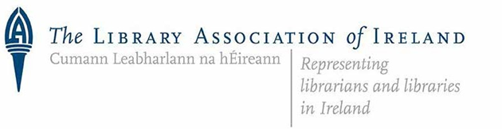

Annual Report 2021

Library Association of Ireland Annual Report 2021

Edited by Cathal McCauley, Trish Nolan, Robert Alfis and Niall O’Brien on behalf of the Association.
With thanks to the Officers and other members of Council, Committees, Taskforces, Groups and Sections for their original contributions.

Cover and Page Footer Art Courtesy of Wise Eyes Creative

Published by the Library Association of Ireland
Dublin
April 2022

ISSN 0791-6248

Contents
Introduction 5
Library Association of Ireland AGM 2021 8
Election of Officers and Council Members 8
Management and Administration 10
Council 10
Council Meetings Schedule and Attendance 10
Management Committee 11
Key items progressed by Council 12
Developing the Profession 14
Education Committee: Professional Standards Committee (PSC) 14
Education Committee: Continuing Professional Development (CPD) Committee: 17
Library Ireland Week 2021 19
Media Literacy Ireland 23
Literacies Committee 24
Communications 26
An Leabharlann: the Irish Library 28
Social Media 29
Supporting Co-operation Between Libraries and Library Organisations European and International 30
European and International 30
North-South Liaison Committee/Annual Joint Conference Committee 32
North-South Liaison with CILIP Ireland 33
Groups and Sections 34
Academic & Special Libraries Section 35
Career Development Group 43
Cataloguing and Metadata Group 50
County and City Librarians’ Section 54
Genealogy and Local Studies Group 59
Government Libraries Section 60
Health Science Libraries Group 62
LAI Library Publishing Group (LPG) 70
Marketing & Communications Group 2021 74
Open Scholarship Group 75
LAI Public Libraries Section 81
Rare Books Group 84
School Libraries Group 88
Western Regional Section 92
Youth Libraries Group Report 2021 96
Acknowledgements 102
Appendices 103
Appendix 1 – Organisation of the Association 104
Appendix 2 - Committees 106
Appendix 3 – List of Abbreviations 108

Introduction

The 2021 Annual Report of the Library Association of Ireland (LAI) is a testament to the commitment, passion, resilience and expertise of our members. 2021 saw us face the reality that what was initially anticipated to be a temporary interruption of all of our lives was likely to be with us for some time to come.

In the face of an ongoing pandemic the LAI could have been diminished as members faced continuing disruption to all aspects of their lives. Instead, the members, and in particular the committees, groups and sections, adapted to these circumstances and continued to do an astonishing array of important work across a diverse range of librarianship. Selected highlights of the work of the LAI during the year include:
- The integration of the Schools Library Group and the development of the Open Scholarship Group within the LAI
- The award of the first An Post Irish Book Award LAI Author of the Year award to Marian Keyes after a very successful process involving members, book clubs and the public
- The success of the LAI/CILIP Ireland Joint Annual Virtual Conference on the theme Libraries: A World of Possibilities
- A wonderful Library Ireland Week around the theme ”Our Future Story: Recharge, Reconnect & Re-emerge”
- The approval of five ALAI awards by the Profession Standard Committee and I encourage members to consider applying for all three of our available awards (ALAI, SLAI and FLAI)
- The launch of the President’s Medal award to recognise people outside of libraries who have a track record of supporting libraries and library related issues. The inaugural medal will be awarded will be made in 2022.
- The launch of the L2L joint digital badge in an initiative of the National Forum for the Enhancement of Teaching and Learning and the Career Development Group.
- The involvement of HSLG in Dublin City Council’s annual One Dublin One Book initiative in April
- The negotiation by the Library Publishing Group of a three-year Strategic Affiliation between the Library Publishing Coalition and the Library Association of Ireland.
- The Public Libraries Section ‘A World in Change: Libraries Survive and Thrive’ online event series
- Continuing preparations for the IFLA World Library and Information Congress to be held in July 2022
- Our leadership of the #ebooksos campaign in Ireland including a series of articles, events and advocacy around the need for reform of the eBooks market

I would like to sincerely thank all who have made the above and the many other wonderful activities of the LAI possible during 2021. I am particularly grateful to the groups and sections and to the members of Council who have been so supportive during my first term as President. Special thanks to Robert Alfis, Niall O’Brien and Trish Nolan who worked so hard on the compilation of this report. Sincere thanks to the groups and sections who submitted reports of their activities to inform the process.

During 2021 I have thoroughly enjoyed working with colleagues in all areas of librarianship and it has constantly reaffirmed my belief in the importance of libraries. I am confident that despite the ongoing and evolving challenges society is facing the LAI and our members will play our role in meeting these challenges and making the world a better place.

Cathal McCauley
President 2021 - 2022,
Library Association of Ireland

Library Association of Ireland AGM 2021

The Annual General Meeting of the Library Association of Ireland took place on Zoom on Tuesday 27th April 2021 at 10.00 am. Due to challenges presented by the continued Covid-19 pandemic, the AGM was conducted in this format rather than as an in-person meeting. A particularly high number of members attended.

Election of Officers and Council Members
The following were elected as Officers and Council Members

Officers:
President: Cathal McCauley, Maynooth University
Vice President: John Shortall, Carlow County Library Service
Vice President: Eileen Morrissey, Wexford County Library Service
Honorary Treasurer: Lorna Dodd, University College Dublin
Honorary Secretary: Niall O’Brien, Royal College of Surgeons in Ireland

Names above were proposed by Jane Burns and seconded by Eva Hornung.

Library Association of Ireland Council:
Clare Conneally, RCSI
Brendan Teeling, Dublin City Libraries
John Shortall, Carlow County Library Service
Christoph Schmidt-Supprian, Trinity College Dublin
Marian Higgins, Kildare County Libraries
Mary Murphy, Meath County Libraries
Eimear McGinn, Offaly County Libraries
Stuart Hamilton, Local Government Management Agency
Jane Buggle, Dublin Business School
Jane Burns, Athlone Institute of Technology
Catherine Gallagher, Dun Laoghaire Rathdown County Council
Yvonne O’Brien, Louth Council Council
Melanie Cunningham, Waterford City and County Council
Marie O’Neill, CCT College
Mary Stuart, Westmeath County Council
Alan Carbery, University College Cork
Michelle Breen, University of Limerick
Eileen Morrissey, Wexford County Council
Aoife Lawton, Health Service Executive
Joanna Finnegan, National Library of Ireland
Fintan Bracken, Institute of Technology Carlow

Names above were proposed by Jane Burns and seconded by Eva Hornung.

Management and Administration
The Library Association of Ireland (LAI) is the professional body representing libraries and librarians in Ireland. The objectives of the Association are to promote and develop high standards of librarianship and of library and information services in Ireland and to secure greater co-operation between libraries.

Council
Council sets strategy for the Association, determines policy and is responsible for the correct and effective running of Association activities as a whole.

Council Meetings Schedule and Attendance

Since the 2021 AGM six meetings of the LAI Council took place during 2021 and 2022 on the following dates: 8th June, 13th July, 14th September, 9th November, 18th January and 15th March.
Name | Number council meetings attended (max 6)
Alan Carbery | 5
Aoife Lawton | 3
Brendan Teeling | 4
Cathal McCauley | 6
Catherine Gallagher | 5
Christoph Schmidt-Supprian | 5
Clare Conneally | 1
Damien Dullaghan | 1
Eileen Morrissey | 5
Eimear McGinn | 3
Eva Hornung [observing] | 1
Fintan Bracken | 6
Isabelle Courtney [observing] | 1
Jane Buggle | 5
Jane Burns | 3
Jo Vahey | 2
Joanna Finegan | 5
John Shortall | 6
Lara Musto [observing] | 1
Lorna Dodd | 5
Marian Higgins | 2
Marie O’Neill | 4
Mary Buckley [observing] | 1
Mary Murphy | 4
Mary Stuart | 2
Melanie Cunningham | 1
Michelle Breen | 6
Niall O’Brien | 6
Robert Alfis | 5
Stuart Hamilton | 3
Yvonne O’Brien | 1

Management Committee
The Management Committee manages the finances and administration of the Association. Members comprised Robert Alfis, Lorna Dodd, Marian Higgins, Cathal McCauley, Eileen Morrissey, Niall O’Brien and John Shortall.

Committee members communicated informally throughout the year and met formally on the following dates: 2nd July 2021, 31st August 2021, 15th October 2021, 11th November 2021, 29th November 2021, 13th January 2022, 4th March 2022 and 11th April 2022.

Key items progressed by Council

- #ebookssos campaign:
On Thursday 29th January 2021 the Association hosted a booked-out online seminar to discuss the eBooks crisis as part of the Association’s ongoing work in concert with the #ebookSOS campaign in the UK. While the importance and benefits of eBooks are acknowledged it is clear that there is a systemic problem with the way eBooks are provided. The Association needs to work with librarians, policy makers and other stakeholders to ensure a more equitable and sustainable approach to eBooks.
- IFLA World Library and Information Congress 2022
In July 2022 Dublin is due to host the International Federation of Library Associations (IFLA) World Information and Library Congress (WLIC) which will see more than 1,000+ librarians from all over the world come to Ireland to discuss this and other library and information related issue. Throughout 2021 work continued to prepare for this significant event.

- LAI Author of the Year Award
The winner of the inaugural Library Association of Ireland’s Author of the Year at the An Post Irish Book Awards was Marian Keyes. The 2021 awards attracted a record number of votes from the Irish public, and audiences around the world were able to watch the An Post Irish Book Awards ceremony as it happened. The ‘Library Association of Ireland Author of the Year’ category is aimed at acknowledging an Irish author whose work has contributed significantly to the reader experience and enjoyment of Irish books.

- Inaugural LAI President’s Medal
The Library Association of Ireland (LAI) in 2022 launched the inaugural LAI President’s medal to celebrate an individual who, while not directly working in libraries, has an exceptional track record of promoting libraries and/or issues of interest or concern to libraries. The inaugural winner of the LAI President’s Award will be announced at the Library Association of Ireland AGM.

Online Council meeting January 2022

Developing the Profession

Education Committee: Professional Standards Committee (PSC)

Officers:
Chair: Gillian Kerins (TUD)
Secretary: Terry O’Brien (Waterford IT)
Committee Members:
Catherine Gallagher (Dun Laoghaire Rathdown Library Service) – Awards
Allison Kavanagh (TUD)
Marian Higgins (Kildare County Council and Arts Service)
Brendan Teeling (Dublin City Libraries) – Awards
Celine Peignen (TUS)

The Committee:
- Manages applications, sets standards, and provides assessment boards for LAI accreditation of programmes offering postgraduate degrees in library and information sciences in Ireland, currently UCD School of Information and Communication Studies and the Dublin Business School.

- Manages applications, sets standards, and provides guidelines for LAI professional awards, currently the Associateship (ALAI), Senior Associateship (SALAI) and Fellowship (FLAI) awards of the Association.

- Monitors and makes recommendations to LAI Council on matters related to professional standards and practice including core competencies for professional librarians and information scientists; the Association’s Code of Ethics; the regulatory framework in which libraries operate; and guidelines for new entrants to the field.

Meetings 2021
26 Jan 2021 LAI PSC and CPD committees' joint meeting
10 February 2021 LAI PSC and DBS review meeting
24 February 2021 LAI ePortfolio & NFTL PACT Digital Badges discussion
03 March 2021 PSC ePortfolio meeting
01 July 2021 Meeting with CILIP on Revised PKSB
19 October 2021 PKSB mapping, UCD Accreditations, LAI Awards

An update on the key elements of Committee’s work during 2021 is below.
Awards 2021
No applications were received for Fellowship award (FLAI).
Five applications were received for Associateship (ALAI).
No applications for the Senior Associateship (SLAI).

Proposal by the PSC to the Council in 2021:
"The LAI PSC propose that for applicants to those awarded with an ALAI on our before 31st December 2016 can apply directly for FLAI with no requirement to have the SALAI, if they meet all other criteria."

Recommendation by the PSC to the Council in 2021:
Following a meeting with CILIP, the PSC agreed to formally confirm and endorse LAI support for the new revised PKSB and requested formal promotion of the tool to LAI members via the CPD group.

Accreditation reviews of course providers
Dublin Business School
The committee had a wide ranging and detailed Annual Review meeting with DBS faculty on February 10th, 2021. Following the meeting the PSC commended the work and engagement of DBS.

University College Dublin
The PSC met with the Faculty of UCD School of Information & Communication Studies via Microsoft Teams on December 2nd, 2020. A wide-ranging and detailed discussion was had covering several areas such as Academic admissions, Curriculum and Programme review, QS World university rankings, Module changes and updates, Engagement with the professional community, CPD, flexible modes of delivery, challenges during the Covid-19 pandemic, pre-admission requirements and work experience placements. The PSC offered congratulations on achieving inclusion in the Top 50 iSchools and acknowledged the work of the UCD SICS during a very challenging period.

Other work
In addition to the above, the Committee provided content for the LAI website; responded to various queries seeking information or advice on topics ranging from online courses; internships; volunteering; accreditation of specific programmes, to queries about the LAI award.

Education Committee: Continuing Professional Development (CPD) Committee:

Eva Hornung (Convenor; CDETB Curriculum Development Unit/TCD), Philip Cohen (Retired), Lai Ma (UCD SICS), Eileen Morrissey (Wexford County Library Service), Mary Murphy (Meath County Council Library Service) and Kathryn Smith (RCSI).

In 2021, most LAI activities were still affected by COVID-19. Nevertheless, the work of the CPD Committee continued and a number of courses were approved.

List of approved courses in 2021:
- LAI CMG Training event
- LAI Library Publishing Group seminar
- Joint LAI-CILIP Virtual Conference
- PACT Digital Badge
- ‘Open to change’ – HSLG Conference

Meetings with the Professional Standards Committee (PSC)
CPD held a joint meeting with the PSC committee on 26th January 2022 to discuss the promotion of awards and the new PKSB scheme.

Meeting with PACT Digital Badge organisers and PSC
Arising from the January meeting CPD organised another focusing on the PACT Digital Badge for librarians on 3rd March 2022. Isabelle Courtney and Mary Buckley joined the meeting. They gave a short presentation on their experience of doing the PACT digital badge with the National Forum (NF) and outlined their proposal for running a pilot joint NF + LAI badge for (initially) teaching librarians. Both committees agreed to promote this excellent initiative.

Library Juice Academy
CPD were approached by an LAI member about a potential partnership with the Library Juice Academy, which is an institution with lecturers who run online CPD courses with assignments and accredited/recognised diplomas. CPD agreed to follow Council’s advice about how to proceed.

PKSB liaison person
Lai Ma is our representative on this panel. She had been in touch with CILIP about how to progress this and a report was sent back to Council.

Library Ireland Week 2021

‘Our Future Story: Recharge, Reconnect & Re-emerge’

Officers:
Chair: John Shortall (Carlow County Council)
Vice-Chair: Johanna Archbold (TUS Library: Midlands)

Committee:
Suzanne Brosnan (Kildare County Council)
Hazel Percival (Wexford County Council)
Justin Smyth (SJOG Research Foundation CLG)
Claire Milliken (CILIP Ireland)
Denise Schroder (CILIP Ireland)
Jo Vahey (Galway County Library Service)

Background
Library Ireland Week took place from Sunday, November 28th to Sunday, December 4th, 2021. The theme of this year’s week was "Our Future Story: Recharge, Reconnect & Re-emerge". The week aims to raise the profile of libraries and information service professionals and showcases their resources, facilities, events and services through dedicated programmes and events.

Throughout the week public libraries, special libraries, business libraries, health libraries, law libraries, academic libraries, prison libraries and government libraries all around Ireland celebrated by showcasing their unique resources, running online events and engaging in a nationwide social media campaign.

Library Ireland Week is an annual initiative of the Library Association of Ireland organized by a taskforce reporting into the Library Council of the Library Association of Ireland. For 2021, Library Ireland Week was again delivered in partnership with CILIP Ireland, as a co-supporter of the Library Staff Champion Award to recognise the significant contribution of library staff across the island of Ireland in these most difficult of years.

Each year Library Ireland Week (LIW) invites libraries across Ireland to host events, campaigns, activities or exhibitions to celebrate the annual theme. 2021’s theme is Our Future Story: Recharge, Reconnect & Re-emerge, in recognition of how libraries and library staff are looking towards a future beyond COVID-19. The public were invited to share what their library has meant to them this year for the LIW Competition using the #LIW21 hashtag.

Events
LIW Events took place online with libraries across the country represented and events were registered and promoted on the LIW website, and many others also took place. See LIW Event Listing for more details: http://libraryirelandweek.ie/events/. Between October and December 2021 there were 24,896 visits to www.libraryirelandweek.ie

Library Staff Champion Award
Library Ireland Week is as much about library staff and the library sector as it is about raising awareness about the diverse and impactful work that happens in libraries every day. To mark and acknowledge library staff for their contributions to the sector and beyond, Library Ireland Week 2021 celebrated the fourth Library Staff Champion Award and invited library staff to nominate colleagues for this recognition. 2021's Staff Champion Award was co-supported by CILIP Ireland as an all-island acknowledgement of library staff contributions at all levels for all our communities.
The Library Champion Award Package comprises of:
- Voucher & Engraved Trophy
- free membership of the Library Association of Ireland and CILIP Ireland for 1 year after the Award

Library Staff were asked to nominate a colleague they felt embodied the positive impact library staff all over the country bring to their workplaces every day under four judging criteria. At the 2021 LAI AGM, in April the Staff Champion Award winner for 2020: Marie Cullen, Maynooth University Library was invited to accept their award virtually.

Collaboration between LAI & CILIP Members on the committee was a very positive development with the Staff Champion Award this year and it is felt that continued contact, committee representation and collaborative activities will grow engagement across the island in this initiative for staff recognition.

LIW Social Media
The LIW Twitter and Facebook Accounts were active throughout the campaign and coordinated with the main LAI account and other accounts of LAI sub-groups. Activity was considerably increased, particularly with the public competition and could be further enhanced in future years.
Thanks to:
The Taskforce Committee would like to thank Cathal McCauley, President of the LAI, the LAI Council and CILIP Ireland for their support throughout this process. Thanks also to Trish Nolan and Brian Doody, LAI Webmasters, Lorna Dodd, LAI Honorary Treasurer and Niall O’Brien, LAI Honorary Secretary. Thank you to Denise Shroeder and her children Frieda and Lukas for featuring in our official launch photoshoot. We would also like to thank Wyse Eyes Creative for their graphic design and publicity material. Special mention to all library staff who nominated colleagues for the Library Staff Champion Award, without whose generosity of spirit, the Award could not have started or continued. Finally, thanks to all the library staff throughout the country who engaged with LIW21 curating and hosting events, bringing the theme and message of Library Ireland Week 2021 to as many of our users as possible.
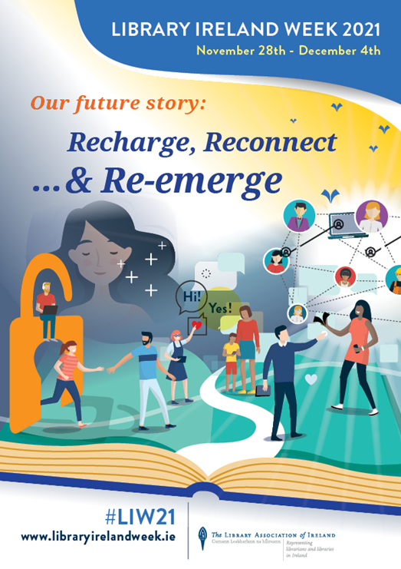

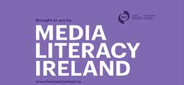
Media Literacy Ireland
https://vimeo.com/323806931

Officers:
Chair of Steering Group: Prof. Brian O’Neill (TU Dublin)
Vice Chair of Steering Group: Stephanie Comey (BAI)
MLI Steering Group LAI Rep: Philip Cohen 2020; Marian Higgins 2021

Media Literacy Ireland (MLI) https://www.medialiteracyireland.ie is an independent association of personal and institutional members committed to the promotion of media literacy across Ireland. Members include Government agencies, advocacy groups and professional bodies – as well as all the major print, broadcast and social media companies. Policy and practice are guided by the MLI Steering Group, a combination of appointed and elected representatives of the membership at large.

The LAI is a permanent member of the Steering Group, recognising the central role that libraries of every sector play in promoting media and information literacy. In addition, much of the work of MLI is undertaken by targeted Working Groups, whose members include large numbers of library staff and library educators.

Be Media Smart https://www.bemediasmart.ie is probably the best-known campaign run by MLI, with its catchphrase Stop, Think, Check. Other activities include regular webinars on topics such as Media Literacy in Europe, Social Media Influencing in Ireland (organised by LAI member Isabelle Courtney), and News Literacy Now. The websites of both Be Media Smart and MLI include abundant links to research and resources related to the subject. Building on the success of the Tactical Tech work in 2020, Meath, Waterford, Dún Laoghaire-Rathdown and Kildare Libraries engaged in further training to deliver media literacy training to members of the public. The participating authorities will work together to deliver a further exhibition and support events in 2022. Finally, membership of MLI is free of charge and LAI members are encouraged to join, access its online resources and become actively involved.

Literacies Committee

Committee:
Philip Russell [Convenor] (TU Dublin), Brenda Carey (Dún Laoghaire Rathdown Libraries) Isabelle Courtney (Dublin Business School), Siobhan Dunne (Trinity College Dublin) Genevieve Larkin (Marino Institute of Education) Claire McGuinness (University College Dublin) Mary Mulryan (Technological University of the Shannon), Emer O’Brien (Cork County Council), Ann O’Sullivan (AL Goodbody), Katherine Ryan (St. Andrew’s College Dublin) Joan Ward, (Libraries Development Unit, LGMA).

The Literacies Committee is committed to reviewing best practice initiatives in terms of literacy, information literacy and digital literacy across all library and information sectors in Ireland and is working on a revised smart action plan for the development of these competencies at local and national level. The Committee actively engages in advocacy, promotion and dissemination activities.

Members were involved with a number of initiatives during 2021 including the ongoing Be Media Smart (BMS COVID-19) - the national media literacy campaign for Ireland which was rerun in 2021 to counter the spread of misinformation and fake news during the Covid-19 pandemic and vaccination programme. BMS COVID-19 helped to advance media and information literacy awareness in Ireland during this crisis and was supported by the Literacies Committee as part of their collaboration with Media Literacy Ireland.
An online meeting of the Literacies Committee took place in December 2021 and the Literacies Committee subsequently made an online submission on behalf of the Library Association of Ireland in response to the call issued by SOLAS as part of the consultation on a new ten strategy for adult literacy, numeracy and digital literacy for Ireland.
The convenor of the Literacies Committee, Philip Russell gave an online presentation in October 2021 as part of Media Literacy Ireland’s Monday Webinar series “MIL and Libraries: On the frontline of the battle against misinformation’. Members of the Literacies Committee also attended this event online.
The Literacies Committee continues to forge strong links with national and international groups as it seeks to collaborate and further its goals around these core competencies in the years ahead.

Expressions of interest in joining the Committee should be addressed to Philip Russell, the Convenor.

Communications
A communications team was established in 2021 to provide an overall, more cohesive approach to LAI communications. Following this, a proposal to form a Marketing & Communications group – a merger of the Marketing Taskforce and Communications Team- was made to, and approved by, the LAI Management Committee and Council.

Website Developments
The website continued to perform well in 2021 with more than 90,000 visits and 30,000 unique visitors. The Careers, Membership, and Events Calendar pages were among the top ten visited.

Many important announcements were communicated to our members, including the launch of the new LAI Author of the Year Award as part of the Irish Book Awards, and promotion of the #ebooksos campaign Ireland. Online conferences, events, workshops and meetings hosted by LAI groups and sections were also widely promoted.

The development and maintenance of the Library Ireland Week website continued and updates to groups, sections and committees were supported. We also welcomed a new group to the association – the School Libraries group – in June 2021. Sandra Turner, Roscommon County Librarian, stood down from her role as Web Officer and we thank her for her hard work in establishing the new website. Trish Nolan, Executive Librarian with Carlow County Library Service, took over the position in July 2021.

As the site is now well established a review of the layout and content commenced. A number of steps were initiated, including:
• A review of mailing lists and removal of those no longer active
• A review of website content and links
• Re-organisation of the homepage, including promotion of articles from an Leabharlann
These are the first steps in further developing the site and making improvements which will better serve our members.

An Leabharlann: the Irish Library

An Leabharlann: the Irish Library was published twice during 2021 Volume 30 issues (1) and (2). It is published by The Library Association of Ireland and The Chartered Institute of Library and Information Professionals (Ireland) with the ISSN: 2009-6062. Current issues and a large number of back issues are freely available to all on open access at and similarly on e-Deposit Ireland at: https://www.libraryassociation.ie/an-leabharlann/

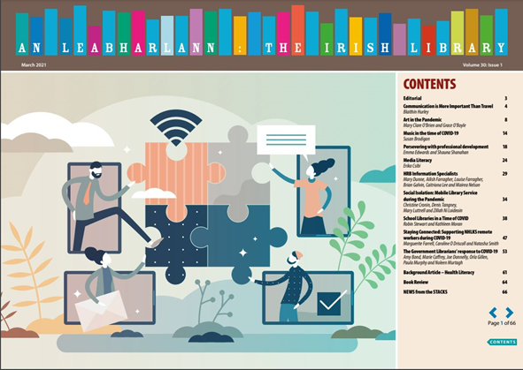
An Leabharlann is edited by Marjory Sliney and the editorial board is Fintan Bracken (IT, Carlow), Kate Kelly (Royal College of Surgeons in Ireland), Claire Milliken (Northern Ireland Assembly), Philip Russell (TU Dublin) and Brendan Teeling (Dublin City Public Libraries). Production/Distribution is provided by Gillian Kerins. The OA Manager is Genevieve Larkin. Proofreading is by Jenny Stokes and Design is by Noel Smyth. The LAI is greatly indebted to Marjory Sliney for editing the journal for so many years.

Social Media
The LAI Social Media Team during 2021 consisted of Saoirse de Paor (Maynooth University) and Aideen Kerr (Kildare Libraries). The Team works closely with Trish Nolan (Carlow Libraries).
The LAI’s social media accounts/platforms are predominantly used to share, promote, advertise and advocate for the great work being done by our public, academic, private semi-private libraries. The social media team will mostly post items when members of the LAI executive, committees or groups ask for something to be promoted or broadcasted. Key figures for 2021 include:

Instagram:
● 1050 followers
● 154 posts
● 349 following

Twitter:
● 4,237 followers
● 11.3k Tweets
● 1,325 following

Facebook:
● 1704 likes
● 2058 followers

Supporting Co-operation Between Libraries and Library Organisations European and International

European and International
During 2021 the LAI maintained close links with international colleagues through participation of its members in the National Forum on Public Libraries in Europe (NAPLE), and the International Federation of Library Associations and Institutions (IFLA). NAPLE met regularly throughout the year to discuss responses to the COVID pandemic in Europe’s public libraries, and shared best practice on elements of COVID response such as health and safety and access to digital resources such as eBooks, as well as hosting webinars for policymakers on the provision of minority language materials in libraries, and innovative methods of delivering library internet access such as the SpaceX Low Earth Orbit (LEO) Starlink programme.

LAI Council Member and NAPLE President Stuart Hamilton was also elected as the new Chair of IFLA’s European Regional Division and member of the IFLA Regional Council and began his two-year term by helping the new Committee develop a workplan focused on supporting librarians in Europe undertake advocacy around the Sustainable Development Goals and internet governance. LAI President Cathal McCauley continued to be an Officer and active member of IFLA’s Library Building and Equipment Section and was a speaker at an online webinet Library Design Matters! For more see https://librarydesignmatters.wordpress.com/ . LAI Vice-President Eileen Morrissey was elected as a member of IFLA’s Public Libraries Section Standing Committee and commenced her term in August 2021. LAI Council member Jane Buggle is the Convenor of the IFLA Library Publishing Special Interest Group.
Lara Musto is the LAI’s IFLA Map of the World Officer. The IFLA Library Map of the World is a data-driven website collating worldwide information on libraries of all kinds for information and as an advocacy tool for the library sector. It includes a short narrative country profile of the library landscape in each country and hosts metrics from different types of library: National, Academic, Public, Community, School and Other. The site also hosts Sustainable Development Goals Stories showcasing how libraries are addressing SDGs and contributing to the UN2030 Agenda for SDGs.
The Library Association of Ireland is the designated data collection and awareness raising body for the IFLA-LMW in Ireland. Lara Musto supported by Linda Kerr and Dr Johanna Archbold. The team coordinate with the IFLA-LMW Project Manager based in The Hague on data gathering and inputting. Through 2021 and 2022 the team have been contacting Irish library groups to gather 2019 data across the sector. As part of the SDG agenda for the IFLA-LMW project, the project team hosted an SDG webinar introducing Irish librarians to the SDG Stories and the workflow for creating a Story through the website. The project team intend to ensure that as much Irish library data for 2019 is live on the IFLA-LMW website as possible, and a number of new SDG Stories from Irish libraries, in advance of the IFLA Conference in July 2022.
During 2021 Philip Cohen chaired the Irish National Committee, helping to organise the forthcoming IFLA WLIC: World Library and Information Congress. Originally scheduled for 2020, the WLIC will take place in Dublin 26-29 July 2022 and is expected to attract at least 1,000 delegates, representing more than 100 countries. A number of LAI members attended the virtual WLIC in 2021 , in order to promote our own Congress in 2022.

Arising from contacts made at WLIC 2019 in Athens, Philip worked closely with IFLA HQ and library colleagues in Ireland to bring the 'Glass Room' media and information literacy exhibition to four public library authorities during 2020-21. See: https://libraries.dlrcoco.ie/events-and-news/library-news/media-literacy-series-disinformation-fake-news-and-privacy-ricardo for how Dun Laoghaire-Rathdown hosted the exhibition and accompanying webinars, workshops and videos.

North-South Liaison Committee/Annual Joint Conference Committee
The 2021 organising committee were: Eva Hornung (Chair), Michelle Breen (Programme), John Shortall (Sponsorship), Fintan Bracken (Sponsorship), Lorraine Marrey (Social Media), Cathal McCauley (LAI President), Lorna Dodd (LAI Treasurer), Alex McIlroy (CILIP Ireland Committee Chair) and Gerardine Blee (CILIP Ireland Representative). The Conference took place online on 2nd and 3rd November 2021 and featured keynote speakers Stephen Abram and Barbara Lison together with many other wonderful speakers. The Conference was a great success and very well received. Due to Covid-19 disruption a joint conference was also held in early April 2021just before the 2021 AGM. The conference was organised by Robert Alfis, Gerardine Blee (CILIP), Melanie Cunningham, Lorna Dodd, Eimear Evans (CILIP), Margaret Hayes, Marian Higgins, Cathal McCauley, Alex McIlroy (CILIP), Claire Milliken (CILIP), Eileen Morrisey, Niall O’Brien, John Shortall, Marjory Sliney, Sandra Turner. Highlights included a keynote by Bobby Seagull, the awarding of the Library Ireland Week Library Staff Champion Award 2021 to Maynooth University’s Marie Cullen and many interesting and useful sessions addressing a raft of library issues and assessing the impact of Covid-19.

North-South Liaison with CILIP Ireland
The meetings of the North South Liaison Committee took place on 20th November 2021, 19th January and 16th March 2022. Much of the discussion centered on the Joint Conference and Covid logistics. Positive discussion enabled the timetabling of Library Ireland Week North and South, which was successfully delivered in the difficult Covid-19 environment. Marjory Sliney the editor of An Leabharlann, reported on its continued success welcoming submissions from both CILIP Ireland and LAI members. A key area of cooperation during the year was the establishment of an all-island Virtual Mentoring Network. This initiative led by CILIP Ireland’s Gerardine Blee and with Vice-President Eileen Morrissey coordinating LAI’s input has proven very attractive to members at all stages of their careers. The scheme is generously supported by a number of experienced LAI members acting as mentors. The pilot phase is underway, and a review will take place in 2022 ahead of a further rollout of the scheme.

Groups and Sections

Membership of Groups and Sections is a benefit of LAI membership. In particular, participation at committee level in a group or section can be a valuable learning and networking experience.
Committees are elected at the Annual General Meetings of each group and section. The election process is advertised to members in advance, and they have documented procedures which operate within the parameters of the overarching Constitution of the Association. Sometimes refinements are made to suit local circumstances, for example creation of time-specific, focused sub-committees or working groups in response to their own priorities.
Members wishing to join a group or section can select it when joining or renewing their Association membership. If interested in joining a specific committee please contact its Chair or Secretary.

Academic & Special Libraries Section

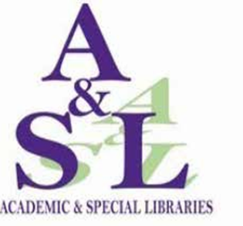

Officers 2021:
Chairperson: David Hughes (ETBI Education and Training Boards Ireland ) – Now Vacant
Hon. Secretary: Dr Johannah Duffy (Mayo County Library)
Hon. Treasurer: Gerard Connolly (TU Dublin – Tallaght Campus) – Now Vacant
Communications Officer: Laura Rooney-Ferris (IT Carlow)

Committee Members 2021
Susan Brodigan (McCann FitzGerald LLP)
Assumpta Byrne (Technological University of the Shannon)
Máire Caffrey (Teagasc)
Dr. Eva Hornung (CDETB Curriculum Development Unit/TCD)
Lisa Lambert (CRANN/TCD)
Fiona Logan (Institute of Art, Design and Technology)
Sue Miller (Dublin City University)
Deirdre McGuinness (William Fry)
Maura Stephens (Galway Mayo Institute of Technology)

Overview
During a year of uncertainty in 2021, the A&SL committee provided support, advice, a community of practice and exchange of ideas to its members. Indeed, its importance became all the more pivotal and distinctive as its members supported the search for information in a time of fast change and adaptability.

Committee Meetings and Membership
The committee met on nine occasions in 2021. This included eight committee meetings and the Annual General Meeting in January. In line with HSE regulations, we moved to online Zoom meetings, which took place on the following dates: 8th February, 30th March, 28th April, 27th May, 21st June, 27th September, 26th October, 24th November.
Two new members joined the committee in 2021, Assumpta Byrne (TUS) and Maura Stephens (GMIT). This year - as part of the 2021-2023 membership cycle - also sees some turnover of membership. The committee is deeply saddened to note that Gerard Connolly and David Hughes are stepping down from the committee. Gerard and David have contributed much to the committee and will all be greatly missed. We would like to thank them all for their hard work and hope to see them at future events. Joining the 2021-2023 committee will be Nadina Yedid (RCPI Royal College of Physicians of Ireland- Heritage Centre) and Paula Madden (GMIT).

AGM 2021
The 2021 AGM was held virtually on Monday 25th January 2021 and 23 members attended. The agenda included the chairperson’s welcome and introduction, the secretary’s report - review of the year, and the treasurer’s report.

A&SL Section events for 2021
“Spoilt for choice or lost in the stacks. The opportunities and barriers to innovative technology adoption in libraries in a post Web 2.0 world.”

On 26th September we held our online event via Zoom. Over 42 attendees listened to lively presentation from Andy Tattersall discussing how we navigate this ever-changing landscape of technology adoption in libraries
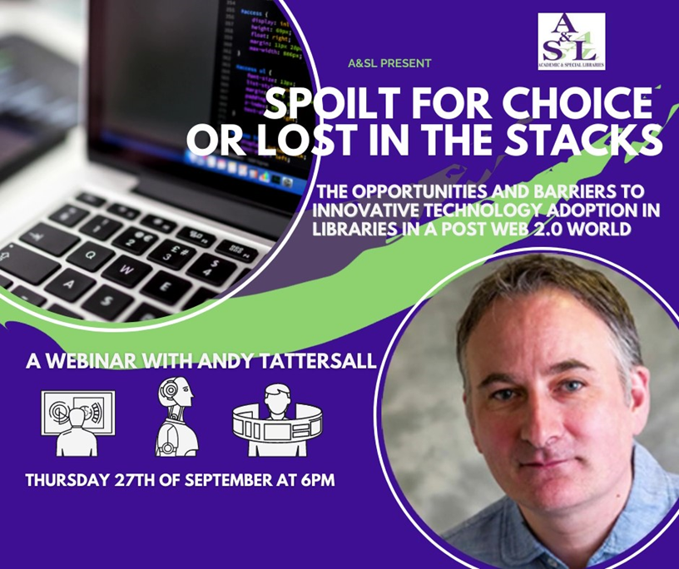

Librarians Aloud
The A&SL ‘Librarians Aloud' podcast series now consists of twenty-seven episodes of librarians talking about their career paths, what they love about the profession and where the information profession is going.
Special thanks to Laura Rooney-Ferris for this series. All episodes available at https://soundcloud.com/librariansaloud/sets/librarians-aloud-episodes

Attendance at LAI Executive Board Meetings and LAI Council Events
Dr. Eva Hornung attended the LAI 2021 AGM and was the convenor of the Continuing Professional Development Committee. She is co-chair of the Volunteer Committee for IFLA 2022 and programme chair for the Joint LAI-CILIP conference, which took place in November 2021, http://conference.libraryassociation.ie/&nbsp; Dr Johannah Duffy and Dr Eva Hornung attended the LAI Meeting of Groups, Sections and Committees, Tuesday 7th September 2021.

Attendance and Presentations at conferences and training events
Assumpta Byrne attended a number of conferences including: Libraries and Open Educational Resources – CONUL on 21st January, UKSG webinar - The importance and use of digital primary sources in teaching and research, 24th February, National Forum Webinar: 'Using OER & OEP for Teaching & Learning', 26th March, How the National PDF informs CPD for Library Staff – LAI, 7th April, Bridging the Divide with Publishers: Lessons learned from a librarian in the publishing world – AIP Publishing, 12th April, IFLA News Media – Deep Fakes: New Frontiers in Disinformation, 4th May, UKSG webinar - Back to the Future: Lessons learned from the Jisc OA Textbook project, 17th June, Academic Libraries North Conference 2021 – Lancaster University, 8th – 9th September, The Paths, Nodes and Edges of Information Literacy Research – UCL, 28th October and FOIL Masters: Emerging Voices in Media & Information Literacy Research, 29th October.
Susan Brodigan attended: Irish Libraries: Living with Covid-19, Maynooth University Library, 20 January 2021, IAML (UK & Irl) Virtual Annual Study Event [VASE21], 13-15 April 2021 and Irish Libraries and Covid -19: First Reflections (Maynooth University Library). Susan also wrote an article for An Leabharlann "Music in the time of Covid-19", published March 2021 https://www.libraryassociation.ie/wp-content/uploads/2021/03/An_Leabharlann_30-1_Full.pdf

Fiona Logan attended: the CONUL Teaching and Learning Annual Seminar - Key Lessons from a year of unprecedented change: academic libraries moving ahead in digital education -on 11th February, The importance and use of digital primary sources in teaching and research, UKSG, 24th February 2021, ‘Catalogue that!’ – ARLIS/UK & Ireland cataloguing workshop (online) 16 April, the LAI/ CILIP joint annual conference - theme ‘Libraries; a world of possibilities’1st, 2nd & 3rd November, ‘VITAL' (Valuing Ireland's Teaching and Learning) presentation 12th November 2021, IADT Dun Laoghaire.

Laura Rooney-Ferris presented at ‘Irish Libraries: Living with Covid’ Jan 20 2021. Laura also contributed a case study to ‘The impact of AI, machine learning, automation and robotics on the information professions’ and a report for CILIP https://cdn.ymaws.com/www.cilip.org.uk/resource/resmgr/cilip/research/tech_review/cilip_%e2%80%93_ai_report_-_final_lo.pdf
Laura also attended the Maynooth Covid and Libraries Response seminar in January and the Open Scholarship 101: Starting the Conversation – LAI Open Scholarship Group, April 22nd.

Máire Caffrey completed a Masters in Science and Health Communication, and training courses in Plain English, Data Stewardship, Science Capital and Scientifically Speaking. Máire attended Build Back Better- Achieving Gender Balance in the Public Service, UKSG: Open Access Lifecycle seminar, SciComm 2021, “Open Scholarship 101: Starting the Conversation” – event held by the LAI Open Scholarship Group, UKSG: Open Scholarship Conference and the NORF Open Research in Ireland Webinar series: FAIRs Fair, Infrastructures for Open Research, Skills, Incentives & Rewards and Open Access.

David Hughes attended the National Forum for the Enhancement of Teaching and Learning in Higher Education Webinar: 'Using OER & OEP for Teaching & Learning' March 2021, #IUADigEd Webinar Developing a Shared Culture of Commitment to Academic Integrity: A Student-Staff Partnership Approach on October 2021 and the LAI OSG Opening up Education: What can Libraries do? November 2021.
David gave presentations: "One bite at a time: Starting OERs in the FET sector" at Libraries and Open Educational Resources: the Present and the Future, January 21st CONUL and "Open Educational Resources” at "Open Scholarship 101: Starting the Conversation”, April 22nd at the LAI Open Scholarship Group.

Eva Hornung attended Irish Libraries: Living with Covid -19, Maynooth University Library, 20th January, the seminar: Getting started with library publishing, Library Publishing Group (Committee Member) on 10th June, Media Literacy Ireland seminar, 4th October, IFLA CPDWL seminar, 13th October, Media Literacy Ireland AGM and webinar, 28th October and “Opening up Education: What can libraries do?” – event held by the LAI Open Scholarship Group on 30 November 2021.

On 13th May, Eva was a guest panelist and gave a lecture on professional development to Master students, iSchool at the University of Sheffield and participated in UCD MLIS Focus Group, 19th May. She was also the Digital Badge PACT for Librarians (Committee Member): http://l2l.ie/; which hosted the LAI and NFTL Joint PACT Digital Badge evening information session on 10th June and lectured as part of the LAI and NFTL Joint PACT Digital Badge (4th October- 15th November). Eva is the co-chair of the Volunteer Team of the National Committee for the upcoming IFLA World Congress 2022.

Johanna Duffy enjoyed a variety of events including: NORF Open Research in Ireland webinars: FAIRs, FAIR roadshow, 16th March, UKSG webinar - Back to the Future: Lessons learned from the Jisc OA Textbook project 17th June, From pitch to publication – Maynooth University, 21st October, "Open Scholarship 2021: the good, the bad and the ugly" 17th & 18th November 2021, The UKSG November Conference., “Opening up Education: What can libraries do?” – event held by the LAI Open Scholarship Group on 30 November 2021.
Johannah taught the Information Management module on the DBS Information & Library Management MSc. and presented on May 13th at the Library Publishing Forum and on 10th June: at the seminar: Getting started with library publishing, Library Publishing Group (Committee Member). She also wrote a Review of IFLA Library Publishing Special Interest Group Virtual Open Programme: Library Publishing: A Catalyst for Change, October 15th 2020, https://www.libfocus.com/2021/05/a-review-of-ifla-library-publishing.html.

Lisa Lambert has been working diligently on the upcoming exhibition of early printed books held at Leiden University Library’s Scaliger Institute, for their contribution to the 2022 European City of Science event https://leiden2022.nl/en. Lisa is also pursuing her PhD, looking into book emigration away from Irish big house libraries after 1922, and their repatriation later in the century.

Deirdre Mc Guinness attended the “Open Scholarship 101: Starting the Conversation” – event held by the LAI Open Scholarship Group on 22 April 2021, “Search Usability” – half day course provided by UK Electronic Information Group (UKeiG) on 14 July 2021 and “Opening up Education: What can libraries do?” – event held by the LAI Open Scholarship Group on 30th November 2021.
Communications
Members can join our emailing list by sending an e-mail to aslsectionevents@gmail.com

Websites:
http://www.aslibraries.com/
https://www.libraryassociation.ie/academic-and-special-libraries-section/

Social media:
Twitter: @ASLIBRARIES
Facebook: http://www.facebook.com/ASLIBRARIES
LinkedIn: Academic & Special Libraries Section of the Library Association of Ireland

Joining the A&SL Section of the LAI:
To join the A&SL Section, select A&SL when renewing your LAI membership

Career Development Group

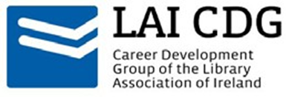

Officers:
Chair: Clare Conneally (RCSI)
Secretary: Aoife Williams (IBAT)
Treasurer: Nicola Smith (RCSI)
Communications Officers: Louise Lawlor (Kildare County Library & Arts Service) and Louise Cooke-Escapil (MU)

Committee:
Stephanie Chen (UCC)
Isabelle Courtney (DBS & MLI)
Saoirse de Paor (MU)
Linda Fennessy (National Library of Ireland)
Alice Morrissey (IADT)
Lara Musto (IBAT)
Conor O’Brien (DBS)
Laura Ryan (UCD)

Committee Meetings and Membership
The committee met on eight occasions in 2021, including the AGM on 29th November 2021. The committee took a break from meetings over Summer. Some committee members attended LAI Council meetings including Clare Conneally and Isabelle Courtney.

Committee Officers and Members 2021 - 2022
Officers:
Chair: Laura Ryan (UCD)
Secretary: Aoife Williams (IBAT)
Treasurer: Alice Morrissey (RCSI)
Communications Officers: Kathryn Briggs (GMIT), Saoirse de Paor (MU) & Lara Musto (IFLA)

Committee:
Stephanie Chen (UCC)
Isabelle Courtney (DBS & MLI)
Louise Lawlor (Kildare County Library & Arts Service)
Nadina Yedid (RCPI)

Goals for 2020 - 2021
- Organise a solo librarians networking event.
- Host 2 – 3 online events
- Collaborate with another LAI group

LAI CDG Events for 2021

Solo Librarian Networking Event
This one-hour online networking event was held on March 25th 2021. The event was an evening of networking for solo LIS professionals. It featured a presentation by Linda Kerr, a solo JCSP librarian working at Killinarden Community School and was well-attended by 44 guests.

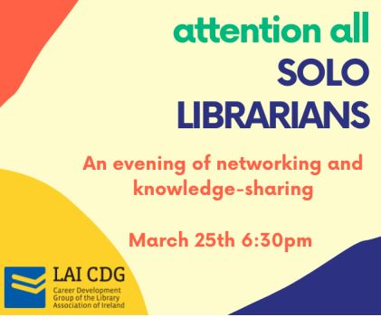

LAI and NFTL Joint PACT Digital Badge
On the 10th of June the CDG held an information event on the new National Forum for the Enhancement of Teaching and Learning/LAI joint PACT digital badge. The librarian-specific digital badge is aimed at teaching librarians or librarians who are seeking teaching roles. This course offers librarians an opportunity to record and reflect on their professional development by mapping CPD activities to both the National Forum PD framework and the LAI Professional Skills Base framework. This 6-week course began in October 2021, there were 73 registrations for this event.
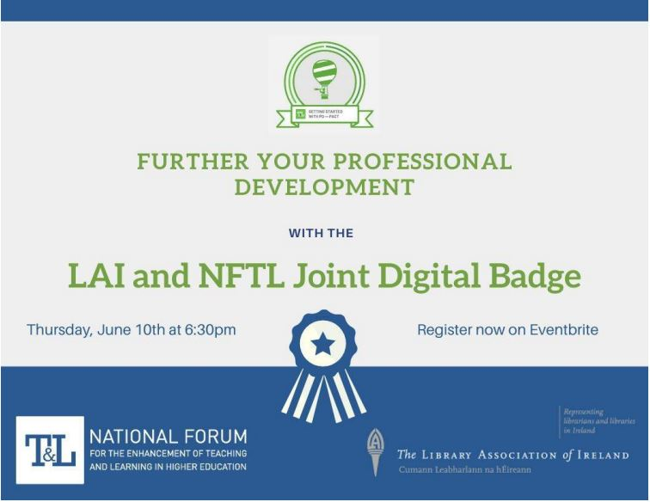

LAI Rare Books Group & Career Development Group Workshop: An Introduction to Special Collections

This sell-out event was held online on Friday 1st October 2021 in collaboration with the LAI Rare Books Group. The maximum capacity of 100 registrations was reached within a few days of advertising the event. This workshop showcased an introduction to working with rare books, special libraries, and unique and distinct collections.
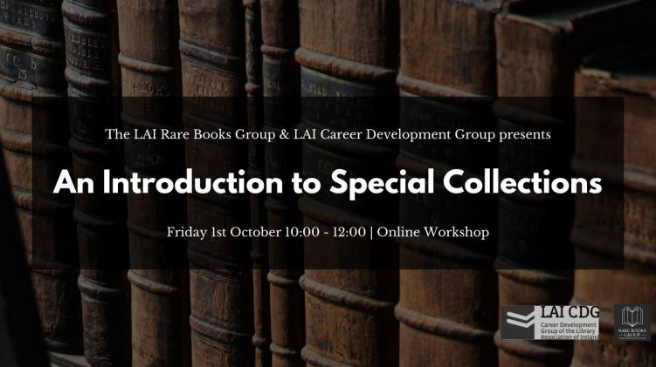
Targeted towards aspiring special collections librarians and early career professionals, speakers included Amy Boylan (Marsh’s Library), Evelyn Flanagan (UCD Library & Chair RBG), Emma Dadson (Harwells), Celine Ward (Chester Beatty Library), Marie Boran (NUIG Library), and a panel discussion chaired by Clare Conneally featuring Alex Caccamo (Maynooth University Library), Margaret Irons (DIAS), and Amy Boylan (Marsh’s Library).

Academic Writing and Continuing Professional Development

On 8th November the CDG hosted Helen Fallon (Maynooth University Library) for an online event about academic writing for librarians. This event was well-attended with 40 registrations and covered topics including why librarians should write for publication, finding topics to write about, where to publish, and how to get started in writing.

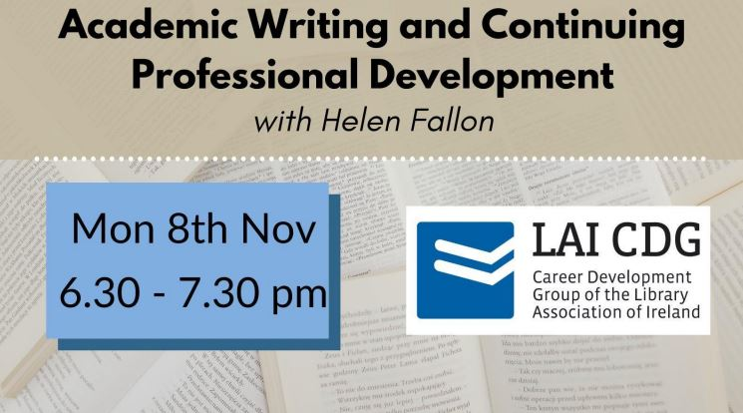

Libraries of Sanctuary: A Roadmap

On 29th November the CDG AGM was hosted alongside an online event about Libraries of Sanctuary. Guest speakers included John Vincent, author of the resource pack on Libraries of Sanctuary, Tiffy Allen, the National Co-ordinator of Places of Sanctuary Ireland, and Suzanne Carroll, Librarian at Laois County Council who took part in qualifying Portlaoise Library as the first Irish Library of Sanctuary. This was a very well-attended event with 80 participants.

AGM

The CDG 2021 AGM was held after the Libraries of Sanctuary event on Zoom. At the AGM Clare Conneally concluded her term as chair, Nicola Smith stepped down as treasurer and Aoife Williams was re-elected secretary. Alice Morrissey was elected treasurer. A chair was not appointed at the AGM. It was decided to elect a new chair at the first meeting of 2022. The committee were advised by out-going chair Clare Conneally that a chair or co-chairs must be appointed for the committee to continue operating as per the policies and procedures of the group. The committee agreed to do a Doodle poll to set the date and time of the next meeting in January.

Communications
Library Association of Ireland: https://libraryassociation.ie/groups-sections/ career-developmentgroup
Join our mailing list by sending an e-mail to laicareerdevelopment@gmail.com Blog: https://laicdg.wordpress.com/
Twitter: @LAICDGroup
Facebook: https://www.facebook.com/Career-Development-Group-CDG-of-the- Library-Association-of-Ireland/

Joining the LAI Career Development Group
To join the LAI CDG, select LAI CDG when renewing your LAI membership.

Cataloguing and Metadata Group

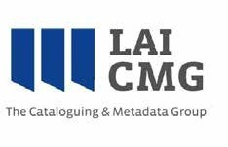
Officers:
Chair: Christoph Schmidt-Supprian (TCD)
Treasurer: Máire Ní Chonalláin (NLI)
Secretary: Patricia Moloney (UL)

Committee:
Ruth O’Hara (MU)
Joe Peakin (Novartis Ireland)
Caroline Philpott (UCC)
Clare Thornley (Clarity Research Services)
Dean Watters (Griffith College Library)

Committee Administrative Work
Ruth O’Hara was elected to the committee at the AGM and took over Yvette Campbell’s role as informal social media officer. At the end of 2021, and formally with the AGM, scheduled for 17 February 2022, the following member stepped down: Joe Peakin. The CMG would like to thank Joe for his contributions and work on the committee.
Mailing list
The group’s membership remained stable; its email distribution list (a Gmail account) stood at 198 addresses at the end of the year.

Meetings
The committee met eight times during 2021, all online via the LAI’s Zoom account: 9 February 2021; 31 March 2021; 5 May 2021; 8 June 2021; 7 July 2021; 13 October 2021; 10 November 2021; and 1 December 2021.

Website
The secretary, Patricia Moloney, designed a WordPress site https://laicmg.wordpress.com/ for the LAICMG (linked to https://www.libraryassociation.ie/) with details of the group’s activities, events, work and links to useful cataloguing, metadata and bibliographic resources.

Training and workshops
The committee organised and hosted two online workshops on ‘Getting Started in Rare Book Cataloguing’ on 2 July 2021, with a repeat on 3 September 2021. The trainer was Anne Welsh from Beginning Cataloguing, who put together a bespoke programme for the CMG. At the end of each day-long workshop, participants left having catalogued three rare books and with knowledge of where to seek further information.
The three books catalogued represent three common periods typically included in special collections:
• One Early Modern book
• One 18th century book
• One Modern (post-1950) book with ‘special collection’ features that make rare book cataloguing appropriate
For each book, Anne Welch discussed the different cataloguing approaches of the three prevalent content standards, AACR2, DCRM(B) and RDA. All model answers were given in the MARC21 schema.
The workshops were certified by the Library Association of Ireland Continuing Professional Development Committee and certificates of attendance were posted out to attendees. Both workshops sold out.

Other outreach and training opportunities
The committee secretary circulated details to the mailing list about cataloguing, metadata, and bibliography-related topics including:
- the IFLA Metadata Newsletter (co-published by the Bibliography Section, the Cataloguing Section, and the Subject Analysis and Access Section) https://www.ifla.org/g/cataloguing/newsletter/;
- the RDA in Europe virtual meeting on 14th September 2021;
- online training opportunities organised by organisations such as National Acquisitions Group, Library Juice Academy, and Beginning Cataloguing.

Annual General Meeting with Keynote Address and Networking
Our AGM and networking event took place on 10 March 2021 as on online event, via the LAI’s Zoom account. It featured three presentations on ‘Remote Cataloguing Projects during Lockdown at the Library of Trinity College Dublin’ with emphasis on the ‘1872 Printed Catalogue Conversion Project’. A report by the CMG secretary was published on the LibFocus blog on 28 June 2021: https://www.libfocus.com/2021/06/remote-cataloguing-projects-during.html

Planning for IFLA
Between January and April 2020, the chair and secretary contributed via online meetings to the planning of two satellite events. These were going to be organised by the IFLA Committee on Standards, the IFLA Cataloguing Section, and the European RDA Interest Group. They were going to be hosted by the library of the Goethe Institut on Merrion Square, Dublin. The CMG was going to lend its support and local knowledge, and probably logistical tools such as its Eventbrite account. The first event, on an RDA cataloguing topic, was to take place on 12 August; the second, on identities management, the day after.
However, they decided to not proceed with satellite events, due to continuing concerns about the ongoing impact of the pandemic.

County and City Librarians’ Section

Chairperson’s Report
The following Officers were elected at the 2021 Virtual AGM on 8th October 2021:
• Chairperson: Catherine Gallagher (County Librarian, Dún Laoghaire Rathdown)
• Vice-Chairperson: Catherine Elliott (Monaghan County Librarian)
• Hon-Secretary: Emma Clancy (Cavan County Librarian)
• Hon Treasurer: Brendan Martin (Wicklow County Librarian)

Since the 2020 AGM, the Section has met on 7 occasions as follows:
• 9th October 2020 (MS Teams)
• 5th November 2020 (MS Teams)
• 3rd December 2020 (MS Teams)
• 4th March (MS Teams)
• 3rd June 2021 (MS Teams)
• 8th October 2021 (MS Teams)
• 2nd December 2021 (MS Teams)

Members of the section were active on steering groups and committees covering a number of areas in 2021 including:

Libraries Development Committee
Chaired by Colette Byrne, Chief Executive, Kilkenny County Council, this high-level committee considers and oversees the development of public library strategy, the work of Libraries Development, LGMA and implementation of the current public library strategy. The County and City Librarian’s Section is represented on this committee by Ciaran Mangan, Meath County Council and Marian Higgins, Kildare County Council. The section thanks Jane Cantwell, Waterford County Council for her representation on the committee.

Libraries Development National Strategy Committees
Three committees with representation from City and County Librarians and Libraries Development, LGMA have continued working to co-ordinate the implementation of the Strategy Programmes and Enablers. A mid-term review of the committee make-up sought expressions of interest from City and County Librarians and their teams. The committees work with Libraries Development, LGMA in the implementation of the Strategic Programmes and Enablers and report to the Libraries Development Committee. Where a National steering group is also in place, the National Strategy committee has representation on the steering group and supports its work.

2021 also saw the continuation of a County and City Librarian’s Forum which met on three occasions 3rd March, 30th March and 7th July. The forum is convened by the Libraries Unit, LGMA. This involves hearing from committee chairs about the work done to date along with feedback from the Libraries Development Committee. City and County Librarians also participated in a Design Thinking workshop facilitated by Libraries Unit, LGMA.

2021 Main Developments
• Services participated in the national Keep Well campaign including the Ireland Reads campaign, which culminated in a reading day on 25th February. This saw 930,000 reading minutes pledged and a Hashtag reach of 9 million on Twitter and 3.5million on Facebook (public pages only)
• The Grow it Forward campaign, another initiative of the Keep Well campaign, saw Libraries Ireland partner with Grow it Yourself. Library services appointed GIY Ambassadors to promote the campaign. Seed packs were distributed to a variety of settings, seedlings shared and produce enjoyed.
• My Open Library – further advancement of the programme took place in 2021
• New stock and LMS tender process completed.
• Right to Read, Healthy Ireland at your Library and Work Matters continued in 2021.
• Dormant Accounts Funding was made available for library authorities to apply for, to continue work with marginalized, socially excluded and disadvantaged communities.
• Library services became heavily involved in supporting the government #keepwell campaign across several activity areas.
• The Creative Ireland programme, including Cruinniú na nÓg, was delivered across local authorities. Many members of this section played a key role in the coordination of the programme as creative coordinators and were also actively involved in the Decade of Commemorations programme.

Covid-19
Public Library services closed their buildings to the public in December 2020 and remained closed until 10th May 2021 when they were able to re-open for lending services with no access to reader spaces/PCs. The next phase of re-opening came in September 2021 when branches could re-introduce some services and it was anticipated that all restrictions would be removed on October 22nd. However, this was not the case and protections remained in place for the remainder of the year.
Throughout this time members have been able to access online services and stock 24/7. The growth in use of digital resources continued an upward trajectory during 2021. Library services developed their online and social media presence to respond to library users queries and to support the health and well-being response to the pandemic. Many services supported community call and library delivery services to those who were cocooning.
Services also pivoted content online creating and promoting a huge variety of online content and developing digital-only client bases. As a section, the County and City Librarians have moved their meetings and workplan online, adapting to the challenge of the situation in a professional and focused way.
The sector has worked since re-opening on providing safe spaces in our libraries for our communities of users. The resilience of everyone and the need for agile responses has made 2021 a challenging and unprecedented year. As a sector we continued to deliver national and local initiatives during the pandemic and were one of the few services that continued to deliver throughout – so while our buildings may have closed, our service never did. This has been recognized by central government.

Bealtaine Book Club Initiative
The County and City Librarians Section partnered again with Age and Opportunity in the nomination of the 2021 Bealtaine Book Club author. The poetry of Paula Meehan was nominated by the section and library authorities ran the programme online during May 2021.

Autumn Seminar 2021
The County and City Librarians’ Autumn Seminar was cancelled due to Covid-19.

Retirement
Bernadette Fennell, South Dublin County Librarian retired in June 2021. The Section would like to formally thank Bernadette for her many years of dedicated service to libraries and the library profession in Ireland.

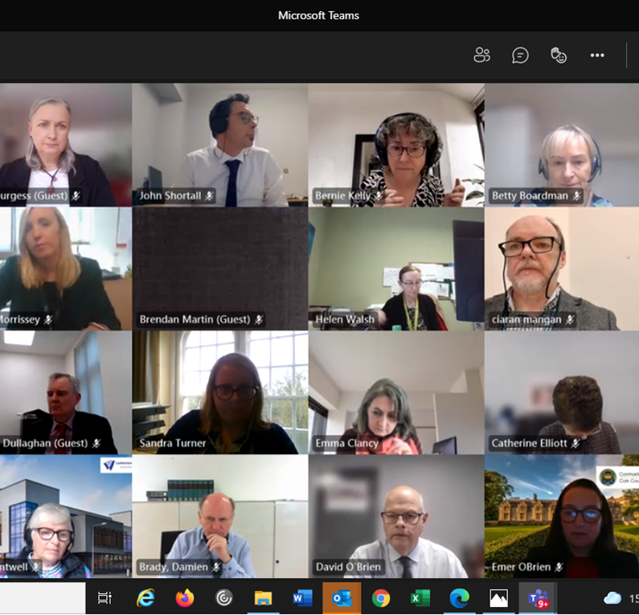
Online meeting of the City and County Librarians’ Group

Genealogy and Local Studies Group

Committee:
Síle Coleman (South Dublin Library Service)
Monica Cullinan (UCD)
Justin Furlong (NLI)
Máire Ní Chonalláin (NLI)
Colette O’Flaherty (NLI)

If you are interested in getting involved with the group or learning more about its work, please contact Síle Coleman at scoleman@sdublincoco.ie

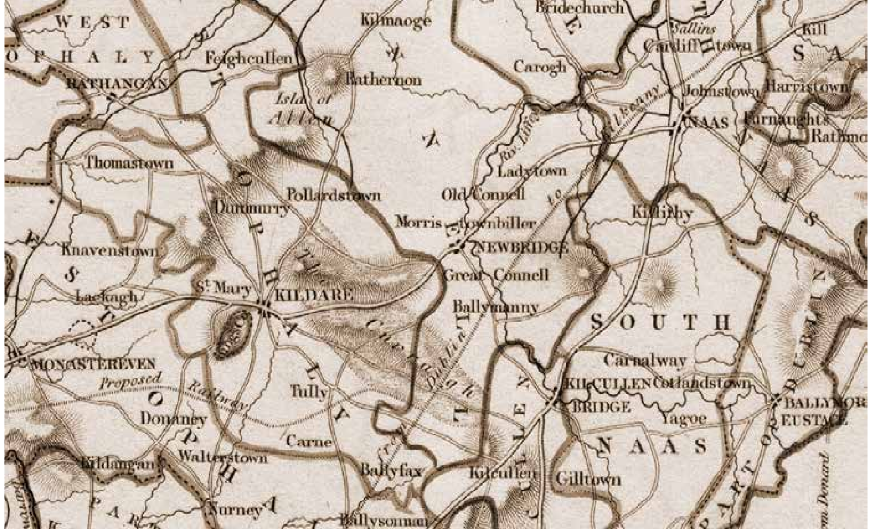
43

Government Libraries Section

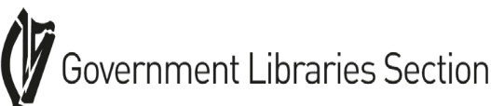

Officers
Chair: Paula Murphy (DPP)
Secretary: Leona Burgess (Office of the Revenue Commissioners)
Treasurer: Máire Caffrey (Teagasc)

The Government Libraries Section (GLS) represents the interests of all staff working in Government libraries. Its aims are to promote and develop the role of libraries in the Civil Service and to promote co-operation between Government libraries.

The GLS held four meetings virtually during 2021 (Feb, May, June and October). Topics discussed at the meetings included discovery software, procurement and initiatives members are involved in in their workplaces (bibliometrics, intranets, websites, SharePoint, media monitoring, alerts, information literacy and book clubs).

The GLS AGM was held virtually in March 2021 and included a discussion on Library Management Systems.

Members of the GLS co-authored an article for the March issue of An Leabharlann entitled “The Government Librarian’s Response to Covid -19”.

Máire Caffrey represented the section on the new LAI Open Scholarship Group.

The GLS were sorry to lose two valued members of the committee towards the end of 2021, Paula Murphy and Leona Burgess. We wish them all the best in their new library roles outside of the government library sector.
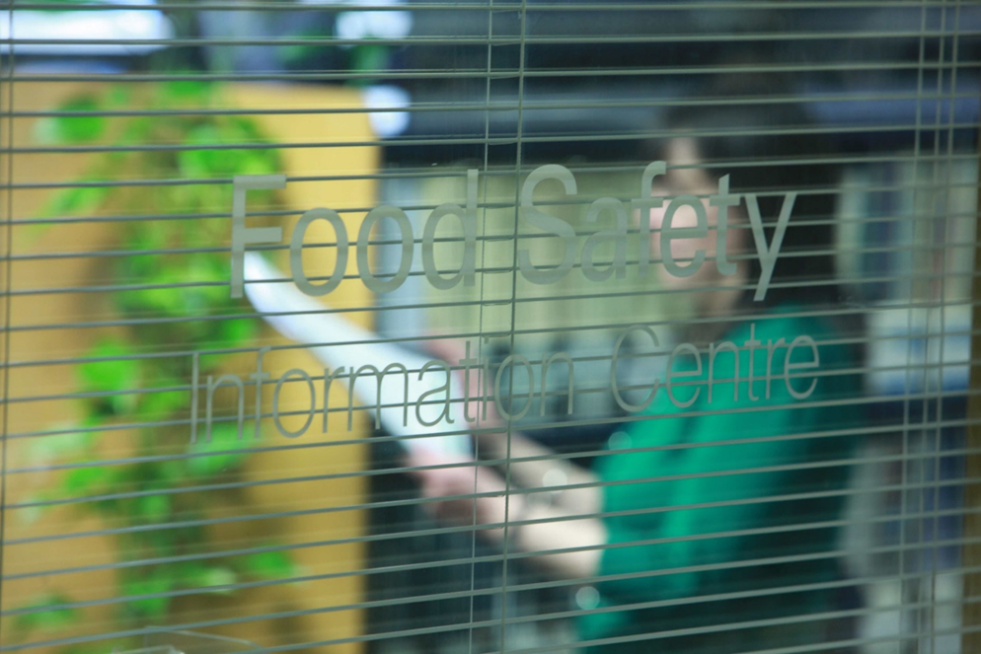

Health Science Libraries Group
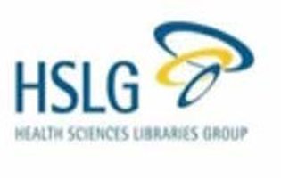
Committee:
Chair: Niamh Lucey (St Vincent’s University Hospital)
Vice-Chair/Research & Communications Officer: Mary Dunne (Health Research Board)
Secretary: Miriam Williams (Our Lady of Lourdes Hospital, Drogheda)
Treasurer: Noreen McHugh (St Michael’s Hospital)

Officers:
Communications Officer: Linda Halton (Our Lady’s Hospital, Navan)
CPD & Events Officer: Mairea Nelson (Health Research Board)

Chair’s Report:
2021 was another busy year for the Health Sciences Libraries Group and, while we may not have had the opportunity to meet one another face to face as we would have hoped, the committee worked very hard to support our members as you will read about in the following officers’ reports.
Our year started with a goodbye to our friend and colleague Michael Doheny who resigned his place on the committee and his position of secretary in December after 17 years of faithful service. Michael was such an intrinsic part of our small group, and his departure has left a big gap.

At the end of 2020, we launched our new HEAnet-hosted discussion list which grew in numbers throughout the year, totalling 87 sign-ups by December. I am pleased to report that the list is very active, and we’ve had some very positive feedback about how great it is to be able to communicate with one another and support one another in this way, while we cannot meet in person.
In April, we were delighted to be involved in Dublin City Council’s annual One Dublin One Book initiative. In recognition of the tireless efforts of Irish healthcare workers throughout the Covid-19 pandemic, the council very kindly made copies of this year’s book, the wonderful Leonard and Hungry Paul by Rónán Hession, available to hospital staff through their libraries.
One of our aims for this year was to compile a new database of HSLG members and to that end, we set up a survey on our discussion list to find LAI members from among those signed up we now have 49 registrations in our system. We hope to work with the LAI Council to grow this number further in 2022.
I was delighted to be invited to attend a meeting of the LAI Groups and Sections on 7 September which was chaired by the LAI President and well attended by council and group/section committee members alike. The president gave an overview of recent changes and outlined plans for future developments with the Association and the HSLG committee looks forward to working closely with the council and other groups and sections in the coming years.
Our biggest disappointment this year was the postponement of our annual conference which we had planned to hold in person in November and, at the time of writing, it remains uncertain if we will be able to proceed with the new date of 17th February 2022. Our greatest achievements, however, were the launch of our virtual journal club in February and the survey on membership of professional librarian associations which we carried out in November, both of which you can read more about in the reports below.
I conclude this report by thanking the HSLG Committee members who have worked so hard and with such good humour over the past year to deliver a vibrant, supportive, and interactive suite of services to our members. I would also like to thank the members themselves for being such a participative group of people, for sharing ideas and for supporting one another. New members are always welcome and can contact the committee on contacthslg@gmail.com or through our website.

Secretary’s Report
The HSLG committee held nine meetings on:
• 15th December 2020
• 26th January 2021
• 25th March 2021
• 13th May 2021
• 12th July 2021
• 7th September 2021
• 11th October 2021
• 8th November 2021
• 22nd November 2021
There were also numerous communications and planning via basecamp and phone etc.

Communications Officer Report

1. HINT

In the past year we have published three bumper issues of the HSLG newsletter HINT. The winter issue will be circulated shortly. On behalf of the committee, our sincerest thanks to everyone who made a submission to HINT this past year. A special word of thanks to our regular contributors: Bernard Barrett, Mary Dunne, Elaine Peppard, Caitriona Lee, and Niamh O’Sullivan. Your contributions are varied, engaging, timely, informative, and appreciated by all. As we head into another new year and consider our plans and aspirations for 2022, we would ask you all to consider sharing your experiences, findings, and insights with others by publishing in HINT.

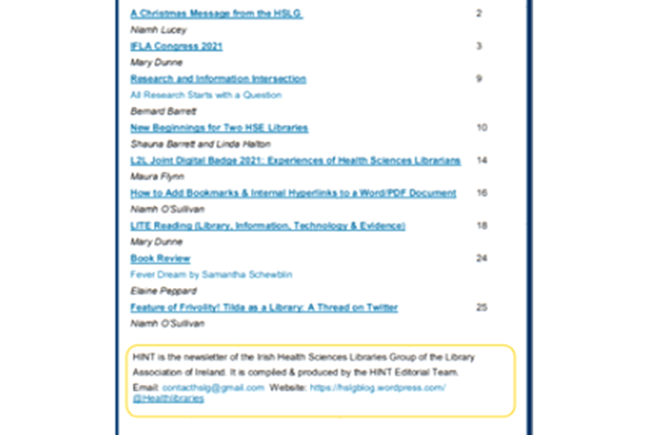

2. HSLG Virtual Journal Club

The HSLG established a virtual journal club in the spring of 2021. The committee facilitates journal club sessions and acts as a central support when needed. We developed a guidance document to assist members, but we keep direction and input to a minimum. This is to enable the journal club to evolve organically, and to encourage collaboration amongst members. Content, themes and topics for presentation and discussion are selected by journal club members, with a recommendation that reading material originate from open access sources. To date, three virtual journal cub sessions have taken place. Our thanks to:

• Anne Madden who presented on the Wikipedia version of “Librarian”
• Breeda Herlihy who led a discussion on reflective practice in health librarianship
• Niamh O’Sullivan for leading an engaging debate around fake news and the COVID-19 pandemic.
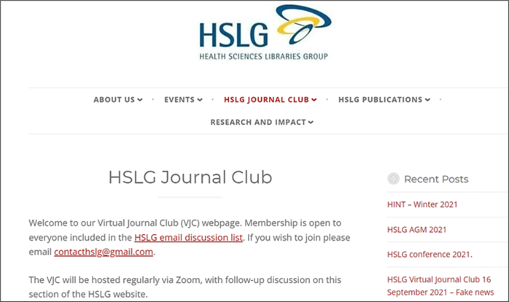
The HSLG Virtual Journal Club continues to grow, and at present has 18 members.
The HSLG website is regularly updated. If anyone has anything they would like us to add to the blog or HINT, please email it to us. We currently have 953 followers on Twitter so if you don’t currently follow us on Twitter, please do at @healthlibraries.
Events Officer Report
As you all know by now, our main event, our annual conference, which was due to take place on the 26th of November 2021 in the Ashling Hotel Dublin had to be postponed. We made this difficult decision in light of the surge in Covid-19 numbers, and because a significant number of delegates and presenters were unable to attend.
It takes a lot of work to organise an event like this, but all is not lost as most presenters and sponsors have already agreed to a new provisional date in 2022.
Julie Glanville will give a virtual talk on the ISSG Search Filter Resource in January. And we expect we’ll have other such events in 2022. All LAI members are invited to attend.
The pandemic has limited our usual CPD events. We have, however, regularly contacted our members by email with information about online conferences and other CPD events and encouraged everyone to avail of our bursaries to cover attendance costs. HSLG members are all entitled to apply for funding to attend relevant courses and other such events. The bursary form is on our website.
We hope you can attend our conference in 2022. As a group, we are all looking forward to getting together. We will send updated details of this and other events when we have them.

Research and Evidence Officer Report
Professional Library Association Survey
In November 2021, the HSLG committee conducted a survey about the perceived benefits of membership in our group and in professional library associations. As an association group, we wanted to understand why librarians have, or have not, become members. We also needed to know what members expect from us, so that the HSLG committee can make informed decisions about activities. This survey was open to librarians/information professionals from any sector based in Ireland. It was promoted through our membership list, discussion email list, the LAI newsletter and via Twitter. We had a 46% response rate from the HSLG group (n=21) and had responses from 28 others. Although the numbers are small, they provide an insight into our members’ views and expectations. We also have a better understanding of the reasons for membership and non-membership in library associations. We will analyse and report on the information collected.

HSLG Virtual Journal Club
In December the Journal of Health Information and Libraries Australasia (JOHILA) published an article about the HSLG virtual journal club, which was set up by the group in February 2021. The committee outlined its role in setting up the club, and the first three presenters gave a short description of their experience. It is hoped that librarians who may wish to set up their own journal clubs may gain insight from our article:
Dunne, M., Halton, L., Herlihy, B., Madden, A. and O’Sullivan, N. (2021) ‘Motorways to boreens: the story of the Irish Health Sciences Libraries Group virtual journal club’, Journal of Health Information and Libraries Australasia, 2(3), pp. 71–80. Available at: https://www.johila.org/index.php/Johila/article/view/88
Abstract
Boreens (from the Gaelic bóthairín meaning little road) are the narrow roads that twist through the Irish countryside. Travel is slower than the busy major roads that cut straight through, but these routes enable the traveller to easily change course as options arise and to discover hidden opportunities for exploration. It is in this context that we share how we moved from the idea of a journal club for health librarians to the reality of an active knowledge sharing group. Through the story of the governing committee and our first three presenters, we explain what is required to drive this kind of club. At the beginning there were so many options and decisions it felt like moving quickly along a busy motorway, often changing lanes to avoid snarl-ups, and watching out for tolls. However, as we settled in for the long haul, we decided to take our own quieter but ultimately more interesting route. We found that if you are clear about your destination, ensure you have sufficient resources, plan carefully but are flexible about how you get there, then you may just enjoy the journey.

AGM 2021
Our AGM took place on 2nd December 2021 at 11am, our second online. There were 26 members in attendance. Individual committee members gave their reports. Mary Dunne, Vice Chair/Research Officer talked us through the results of the Professional Library Association Survey. Mairea Nelson was nominated for another term on the committee.

LAI Library Publishing Group (LPG)

2021 was a busy year for the LAI Library Publishing Group (LPG). The inaugural LPG webinar was held in June, comprising presentations by members from six institutions on the theme of “Getting Started with Library Publishing”. Ann Okerson, IFLA Board, closed the event with some words on the values of library publishing. Committee members were active nationally and internationally, speaking at events, working on committees, launching new library published journals and even launching an Academic Press in TUD. The committee also negotiated a three-year Strategic Affiliation between the Library Publishing Coalition and the Library Association of Ireland.

MTU library launched a new student-led, library published journal
The International Undergraduate Journal of Health Sciences.

Marie O’Neill (CCT) and Jane Buggle (IADT) contributed to the draft version for open comment of the NORF Nation Open Research Landscape Report.

Jane Buggle was on the organising committee of the Library Publishing Forum 2021.

Dr Johannah Duffy (MIE) presented at the Library Publishing Forum on May 13th The potential of Library Publishing Services to transform scholarly communication in Ireland

Dr Johannah Duffy’s A Review of the IFLA Library Publishing Special Interest Group Virtual Open Programme: Library Publishing: A Catalyst for Change held on October 15, 2020., published in LibFocus, May 21st.

The inaugural LAI LPG webinar was held on June 10th: Getting Started with Library Publishing, chaired by Dr Eva Hornung (CDETBI) with guest speaker, Ann Okerson, IFLA Board.
Other speakers included:
• Aisling Coyne (TU Dublin): The genesis of a successful library publishing program
• Fiona Morley (MU) Piloting open publishing initiatives at Maynooth University Library
• Sinead Hanrahan & Shane Cusack (MTU) Faculty, librarians & students as publishing partners: the International Undergraduate Journal of Health Sciences
• Dr Johannah Duffy (MIE): The development of library publishing with faculty
• Niamh Brennan (TCD): Getting on… the TCD SOAPbox: A new generation of Open Access publishing bubbles up in Trinity College Dublin
• Marie O’Neill (CCT): Setting up an Open Access, peer-reviewed, library-published journal in business: ethos, content, and quality
• Robert Alfis (ETBI): The role of a managing editor
• Jane Buggle (IADT): Library publishing curriculum and other teaching and learning materials

Library Publishing: Next Generation Tools Interview with Katherine Skinner and Brandon Locke (Educopia Institute). Interview conducted by Jane Buggle (IADT) and Graham Stone (JISC). Convenor: Ann Okerson. IFLA World Library and Information Congress, August 18th

Margaret Irons’ (School of Celtic Studies, DIAS) review of the LPG webinar was published in LibFocus on August, 25th
https://www.libfocus.com/2021/05/a-review-of-ifla-library-publishing.html
Fiona Morley (MU) spoke at the NORF event, Open Access and Bibliodiversity in Irish Scholarly Publishing, August 26th https://norf.ie/index.php/2021/08/17/open-access-and-bibliodiversity-in-irish-scholarly-publishing/

TU Dublin launched a new journal, The International Journal of Tour Guiding Research

TU Dublin launched their Academic Press through the European University of Technology (EUt+) Project: https://arrow.tudublin.ie/eutpress/

A three-year Strategic Affiliation was established between the Library Publishing Coalition and the Library Association of Ireland, November

Niamh Brennan (TCD) taught the Library Publishing Curriculum on the Open Librarianship module of the MSc Information and Library Management at Dublin Business School

Jane Buggle and Marie O’Neill are committee members of the IFLA Special Interest Group on Library Publishing

9 Irish institutions are included in the Library Publishing Directory: CCT, DBS, Griffith College, IADT, MTU, MU, TCD, TU Dublin, and UL.

Five Irish institutions are included on the 2021 IFLA Global Library Publishing Map – CCT, DBS, MTU, MU, and TCD.

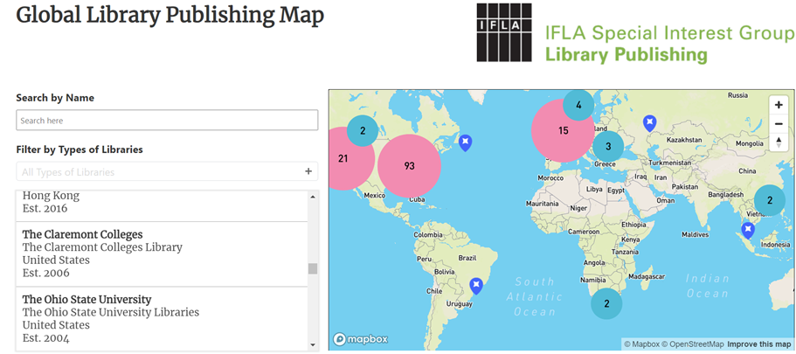

Marketing & Communications Group 2021
Members:
Convener: Mary Murphy (Meath Library Service)
Aoife Lawton (HSE Health Service Executive)
Joanne Gillivan (Technological University of the Shannon)
Suzanne Brosnan (Kildare Library Service)
Patricia Nolan (Carlow Library Service)
The group met online in 2021 due to Covid-19.

The main work of the taskforce this year was to produce a strategy with the key goals of increasing membership of the LAI across all categories and increasing awareness of LAI events and activities among all stakeholders. The 2021-2022 strategy was submitted to the June meeting of the Council in 2021 and was approved. The main action this year was to produce a video promoting the LAI. After getting quotes from different suppliers, Together Digital was selected to produce the video. The team worked on acquiring material for the video including photographs and quotes from members and interviews with members were organized for filming. The video will be completed in 2022.

During the year the communications group got in touch with the proposal to create a Marketing & Communications Group to facilitate collaboration between both groups. This was brought to the Council and approved. It was agreed that:

• This group would be split into two teams - Marketing and Communications
• Each team will continue with their own meetings etc.
• The communications team will develop their own section on the group page with contact details, form templates etc.
• A representative of the communications team will join the existing committee - this will link both teams; Patricia Nolan agreed to join the group and represent the Communications team.

Open Scholarship Group

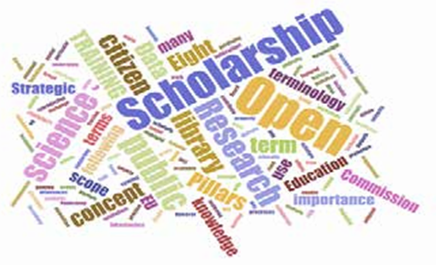
Interim Officers:
Interim Chair: Michelle Dalton (UCD)
Interim Secretary - Fiona Morley (Maynooth University); Breda Connell (IT Carlow)
Interim Events Officer: Marta Bustillo (University College Dublin)
Interim Communications Officers: Tania Marsh (TUS); Justin Smyth (SJOG)

Committee:
Máire Caffrey (Teagasc)
Philip Cohen (LAI)
David Hughes (ETBI),
Pádraig Manning (HSE),
Deirdre McGuinness (William Fry),
Mark Reid (Kildare County Library and Arts Service),
Shona Thoma (Kildare County Library and Arts Service),
Debora Zorzi (CCT)

Open Scholarship, Open Science or Open Research aims to make research data, publications, educational resources and software - in science, engineering, arts, humanities and social sciences - freely accessible to all members of society and in ways that facilitate their reuse. It is a global movement, often led by libraries and library staff.

The Library Association of Ireland supports Open Scholarship principles and in late 2020 established its own Open Scholarship Group, under the leadership of Philip Cohen, to promote the concept and to share best practice. Following its establishment, the group’s first task was to define and agree its Terms of Reference, rules and procedures, which are available on the LAI website. The mission of the group is to support open scholarship activities in libraries and in wider society.

Meetings and Administration:
During 2021, the group held nine meetings via Zoom and achieved a number of successes. The inaugural meeting took place on 22nd January 2021, chaired by Philip Cohen and with eight in attendance. After a number of meetings, an interim committee was put in place and membership of the group expanded.

During 2021, Laura Rooney Ferris stepped down from the group after moving to a new role, and Pádraig Manning (HSE) joined the group to provide input from the perspective of health libraries. Andrew Dillon and Doreen Lumsden also stepped back from the group due to commitments with the new LAI School Libraries Group. We wish all success in their new roles. In early 2022, Debora Zorzi (CCT) joined the group, and we are delighted to have Debora on board. Members of the group currently include staff from a range of public, academic, health and special libraries, and new members are always welcome.

An email address openscholarship@libraryassociation.ie was set up for the group to enable members to make contact with us. A group twitter account @OSGLAI and a You Tube channel were also created. A group mailing list was set up on HEAnet LAI-OPEN-SCHOLARSHIP@LISTSERV.HEANET.IE. In keeping with the ethos of the group, the open science framework platform was chosen to host meeting documentation.

Events:
On 22nd April 2021 a panel discussion on the topic of “Open Scholarship 101: Starting the Conversation” was held via zoom to launch the group. The event was very successful with well over 100 in attendance from across all library sectors.

Speakers at the event were: Michelle Dalton, UCD; David Hughes, ETBI; Rhoda Kerins, DEPR; Aoife Lawton, HSE; and John Shortall, Carlow County Library.

Each speaker gave a short five-minute overview on open access library resources; open educational resources; government open data; open scholarship in health libraries; open scholarship and public libraries respectively focusing on examples of open scholarship in practice. This was followed by a round-table panel discussion chair by Justin Smyth and Q&As from the audience.
Videos of the event are available on the LAI OSG YouTube channel.

On 30th November 2021, another online event was held on the topic of ‘Opening up Education: What can Libraries do?’ to coincide with Library Ireland Week 2021. This event focused on Open Educational Resources (OERS). Open Educational Resources (OER) are defined by UNESCO as teaching, learning and research materials in any medium – digital or otherwise – that reside in the public domain or have been released under an open license that permits no-cost access, use, adaptation and redistribution by others with no or limited restrictions.

A diverse range of speakers at the webinar provided both local and international insight:
● Paola Corti, Open Education Community Manager at SPARC Europe
● Roberta de Franco, Eindhoven University of Technology Library
● Ailish Larkin, Librarian at Shannon College of Hotel Management, NUI Galway
● Kris Meen & Hardy Schwamm, NUIG Library

This was followed by a question-and-answer session. Over 70 people were in attendance via zoom and recordings are available on the Group’s YouTube Channel.

NORF Landscape report
In May 2021, the group submitted a written response to the public consultation on the draft version of the NORF (National Open Research Forum) Landscape Report led by Justin Smyth and Máire Caffrey on behalf of the Group. The group submitted comments across areas of:
● Open Access to Research Publications
● FAIR Research Data
● Infrastructure for Access to and Preservation of Research
● Skills and Competencies
● Incentives and Rewards
The conclusion of the group’s written submission noted:
“Library staff and information professionals frequently act as support to researchers as well as being dedicated promoters of Open Research and Open Access, in a multiplicity of roles. The report goes a long way to recognising their endeavours, but we feel that there are areas where this could be elaborated. There is scope, for example, to highlight the roles that librarians play in providing support to researchers about publishing choices and decisions, and in acknowledging the training, infrastructure and staffing supports required to allow this. This is something that could be meaningfully incorporated into a consideration of Incentives and Rewards too – acknowledgements of librarians’ contribution can tend to be omitted.“

Plans for 2022
The Open Scholarship Group plans to hold its inaugural AGM in 2022, and formally elect officers. The group hopes to engage with other LAI groups to collaborate on joint events to help embed open scholarship principles and practice across different library sectors, and to share learning, knowledge and ideas.

Get In Touch
Contact openscholarship@libraryassociation.ie for further information
Twitter: @OSGLAI
LAI Open Scholarship Group YouTube Channel
Subscribe to our mailing list

LAI Public Libraries Section

Officers:
Chair: John Shortall (Carlow County Library Service)
Vice-Chair: Josephine Vahey (Galway Public Library Service)
Secretary: Mary Murphy (Meath County Library Service)

Committee:
Melanie Cunningham (Waterford County Council)
Emer Donoghue (Galway Public Library Service)
Jackie McIntyre (Offaly County Library Service)
Brendan Teeling (Dublin City Libraries)

Due to the Covid-19 public health emergency, the usual physical conference organised by the Public Libraries Section committee would not be possible and plans were made to deliver an online conference in its place. The organising committee organised and scheduled a series of online talks, interviews and events based on the overall theme of ‘A World in Change: Libraries Survive and Thrive’ which launched in late 2020 and continued until May 2021.

The online sessions were divided into the following headings:
1. Books the simple bare necessities, forget about your worries and your strife
2. Uncertain times: The reading bug is here to stay
3. Wellbeing, mindfulness and resilience
4. Shared reading in a digital land
5. Our popular ‘my life in books’ session.

The titles of the events broadcast in 2021 were as follows:
• Thursday 28th January 11am: ‘Books: The simple bare necessities, Patricia Forde in conversation with author Cathy Rentzenbrink’
• Thursday 11th February 11am: ‘The role of social media for libraries in a COVID-19 world’ Joanne Sweeney on Social Media Marketing.
• Thursday 25th February 11am: ‘Uncertain times: the reading bug is here to stay’. Writer Patricia Forde in conversation with Sasha de Buyl, Director of Cúirt

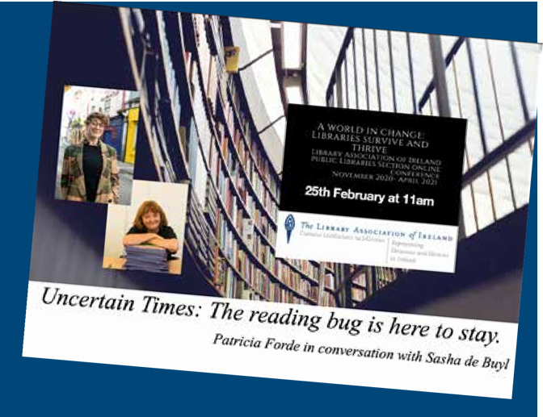

• Wednesday 10th March 11am: ‘Managing our Mental Health through the COVID-19 Pandemic’ with Dr Keith Gaynor, Assistant Professor in Clinical Psychology
• Wednesday 24th March 11am: ‘Shared reading in digital land’ Patricia Forde in conversation with Jane Davies founder and director of ‘The Reader’ Liverpool
• Wednesday 14th April 11am: Krystal Vittles from Suffolk libraries: author of the Guardian article ‘Why lockdown was the plot twist that libraries needed.’
• Wednesday 21st April 11am: ‘Burning the Books’: Richard Ovenden, Bodleian Librarian in conversation with by Jane Burns
• Wednesday 28th April 11am: My Life in Books chaired by Pat Lonergan with guests Minister Paschal Donohue, Arnold Thomas Fanning and Elaine Feeney.

The committee would like to thank the LAI Council, LAI members and public library staff from around the country who engaged with them and provided support during 2020.

Rare Books Group

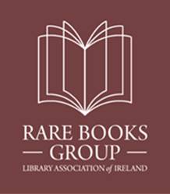

Officers:
Chair: Evelyn Flanagan (University College Dublin); Secretary: Sophie Evans (Royal Irish Academy);
Interim Secretary: Jane Rooney (Dublin City University)
Treasurer: Alexandra Caccamo (Maynooth University)

Committee:
Elizabethanne Boran (Edward Worth Library), Marie Boran (NUI Galway), Stephanie Breen (Trinity College Dublin), Elaine Harrington (University College Cork), Sue Hemmens (Marsh’s Library),Margaret Irons (Dublin Institute for Advanced Studies), Hugh Murphy (Maynooth University), Máire Ní Chonalláin (National Library of Ireland), Sarah Timmins (Royal College of Surgeons Ireland) and Celine Ward (Chester Beatty)

During 2021 Hugh Murphy (Maynooth University) was replaced by Alexandra Caccamo and June Rooney (Dublin City University) became interim secretary when Sophie Evans (Royal Irish Academy) stepped down from the committee.

The committee met five times during the year, 21st January, 4th May, 28th June, 3rd September and 3rd November.

Events
The AGM took place online on 8th March. Evelyn Flanagan, Sophie Evans and Alexandra Caccamo were re-elected to their respective offices of chair, secretary and treasurer.
Following the AGM, Anne Marie O’Brien, School of Celtic Studies, DIAS, gave a presentation on ‘Twenty Years of Script on Screen.’

Workshop
The Rare Books Group annual workshop took place online on 1st October. Organised in collaboration with the Library Association of Ireland’s Career Development Group, the focus of the event was to give early career professionals and aspiring special collections librarians an insight into working with rare books and unique and distinct collections.
Presentations included an overview of the material found in special collections along with its handling and care, a working day of a special collections librarian and routes to professional development. The workshop concluded with a panel discussion, chaired by Clare Conneally of the CDG, on the training and recruitment of special collections librarians.

Annual Seminar
The 2021 Annual Seminar took place on Friday 3rd December and focused on writings in the Irish language in special collections in Ireland. The seminar was held online via Zoom and the recordings made available on the RBG WordPress. The seminar comprised the following presentations:

• If bibliographies could speak … Clóliosta and the history of print culture in Irish / Michela Hoyne, School of Celtic Studies (DIAS)
• UCD’s Ferriter and Morris Manuscript Collections / Meidhbhín Ní Úrdail MRIA, Associate Professor, School of Irish, Celtic Studies and Folklore, UCD
• Irish Language Collections in the National Library of Ireland / Gerard Long, Assistant Keeper, Department of Special Collections, NLI
• Lámhscríbhinní de hÍde and others: Irish Language Manuscripts, James Hardiman Library, NUI Galway / Marie Boran, Special Collections Librarian, James Hardiman Library, NUI Galway
• Eugene O’Curry’s Gaelic Manuscripts, the Colm Ó Lochlainn Manuscripts and other Manuscripts in UCD Library / Evelyn Flanagan, Head of Special Collections, UCD Library
• The Irish Language Manuscripts in the Library of Trinity College Dublin / Caoimhe Ní Ghormáin
• A Call for Public Aid: Forming & Developing UCC’s Irish Language Manuscript Collection / Elaine Harrington, Special Collections Librarian, UCC Library
• Irish Language Manuscripts in the Royal Irish Academy / Meadhbh Murphy, Deputy Librarian, RIA
• Gaelic Manuscripts in the Russell Library, Maynooth / Yvette Campbell, Assistant Librarian, Collections & Content, NUIM

School Libraries Group

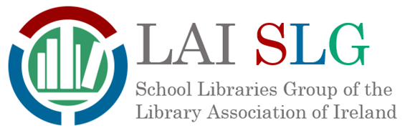

Officers:
Chair Kathleen Moran (JCSP Libraries)
Secretary – Andrea Dillon (Blackrock College, Dublin)
Treasurer – Robin Stewart (JCSP Libraries, Mount Carmel and Larking Community College)
GRA Coordinator – Joan Kelly (The King’s Hospital, Dublin)
Website - Katie Dickson (Wesley College, Dublin)
Social Media - Linda Kerr (JCSP Libraries, Killinarden Community School, Dublin)
Aileen Ivory (Belvedere College, Dublin)
Jane O’Loughlin (Clongowes Wood College SJ, Co. Kildare)

The LAI School Libraries Group was formed in 2021. It evolved from the School Library Association of the Republic of Ireland (SLARI), which was a branch of the UK School Library Association from 2000 to 2021. We as a group have been very happy with our move and look forward to collaborating with other groups within the LAI.

What we do
We believe that every school in Ireland should be provided with resources for a school library run by a qualified librarian, where each school child will have guided access to a wide and diverse range of material for pleasure reading, research, learning and literacy. Our purpose is to represent school libraries by:
• raising awareness of their value within the library and educational sector;
• promoting best practice;
• giving a public voice to school libraries and their staff,
• promoting reading for pleasure and other school library activities
• collaborating with other LAI groups and organisations.

Meetings and Webinars
Our AGM was held online with a great turnout from members. We elected our new officers and welcomed members to our new group. The committee has had several online meetings throughout the year. Our members were invited to two webinars hosted by Media Literacy Ireland: Media Literacy and Libraries and Meeting the media literacy needs of children and young people where our secretary, Andrea Dillon gave presentations on how Media Literacy can be promoted in schools.

Main Developments
• Development of new website https://schoollibrariesireland.com/ that provides further details on the work we do
• We submitted a report to the Oireachtas Committee on Education, Further and Higher Education, Research, Innovation and Science on the part school libraries can play as part of the examination of Leaving Certificate Reform. This report is due to be published shortly, in the meantime the topic of school libraries has been brought up by the chairperson of the committee during public sessions in the Seanad. Our recommendations include:
- Establishing a National Advisory Group on School Library Provision – with a view to developing a National Strategy for School Libraries.
- Recommencing the expansion of the JCSP Demonstration Library Project, as committed in the 2005 DEIS Action Plan as the first step to rolling school libraries out nationwide.
- The Immediate expansion of the JCSP Library Project Digital Library Service to all second level schools.
• A statement was released by the committee in response to the March 2022 announcement by the Minister for Education on the expansion of DEIS supports to further schools, which did not include a reference to the 2005 DEIS Action Plan commitment to expand the JCSP Demonstration Library Project. https://schoollibrariesgroup.files.wordpress.com/2022/03/lai-slg-statement-on-deis-expansion.pdf
• Great Reads Awards ceremony took place virtually on World Book Day. This is a School Library Group Award, and its’ aim is to highlight new authors and to diversify the reading of young adults and young people. Congratulations to this year’s winners: Sue Divin, who won the senior category for Guard Your Heart and Caroline O’Donoghue who won the junior category for All Our Hidden Gifts.
• Social Media Accounts have been set up. The group can be found on:
o Facebook: School Libraries Group, Library Association of Ireland
o Twitter: @SLG_LAI
o Instagram: @schoollibrariesgrouplai.
• A list of suppliers and services that support school libraries has been compiled and shared as a useful tool for teachers/librarians involved in setting up new school libraries.

Western Regional Section

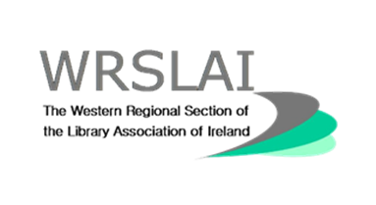

Officers:
Co-Chairs - Celine Peignen (TUS Midlands) and Ailish Larkin (Shannon College of Hotel Management, NUI Galway)
Secretary - Niamh O’Brien (TUS Midlands)
Treasurer - Ailish Larkin (Shannon College of Hotel Management, NUI Galway) - Currently on maternity leave to this role is temporarily being taken care of by Celine Peignen.

Committee:
Michelle Breen (UL)
Michael Doheny (TUS Midlands)
Emmet Keoghan (TUS Midlands)
Samantha Morrissey (Clare County Library Service)
Stephanie Ronan (Marine Institute)
Carolyn Tunney (Roscommon County Library Service)

2021 was another difficult year for all who work in libraries. Due to the pandemic many of the committee members are struggling to make time for the WRSLAI. Through 2021, we continued to support each other while reducing the workload. We did not host any independent events this year. We look forward to continuing into 2022 and hope to return being a more active committee in the near future when we can meet again in person.

Annual General Meeting
The 2021 AGM was held over Zoom on 26th February, ten people attended. Chairperson Michelle Breen opened proceedings by welcoming everyone to the AGM. Tara Considine gave an account of the previous year which included our AGM in January 2020, the WRSLAI planning day in February, the Online Networking Event in June and our participation in Library Ireland Week 2020. Ailish Larkin gave an update of the treasurer’s report which included a query on banking fees, dealing with a hoax text and the possibility of using Revolut or An Post in the future. Emmet Keoghan gave an update on communications. Committee members and officer positions were decided and elected as listed above.

Plans for 2021 included:
1. Remain active on social media
2. Review our internal communication platform Freedcamp
3. Documenting the post-covid opening of public libraries
4. Continue to support each other during the ongoing pandemic

Social media activity
In 2021 we remained active on social media by live tweeting the CILIP Ireland and LAI2021 virtual conference and supporting libraries in our catchment area by cross posting their content.

Reopening of Libraries 2021
Published on our WRSLAI blog in June Carolyn Tunney wrote a posted entitled “The Reopening of Roscommon Library Service after Restrictions were lifted in May 2021.” Carolyn’s post documented how library services were managing change and how users were responding to the library reopening.

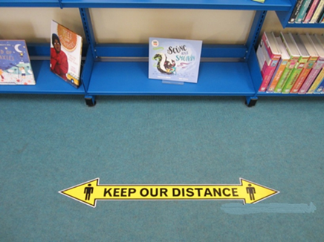

Grow it Forward Participation
We had a committee member participate in the “Grow it Forward” initiative rolled out in public libraries and post updates and progress pictures online of her successes.

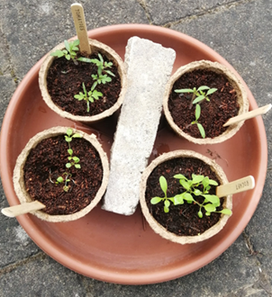

Contacting WRSLAI
All communications with our members are delivered via our Twitter account @wrslai, our blog, and via the LAI mailing list. Our email address is westernlibraries@gmail.com

Youth Libraries Group Report 2021

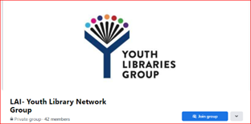

Officers:
Chair: Martina Needham (Offaly County Library Service)
Vice Chair: Emma Doran (Kildare Library Service)
Secretary: Karen McCague (Monaghan County Library Service)
Assistant Secretary: Kayleigh Murphy (Mayo County Library Service)
Treasurer: Trish Nolan (Carlow County Library Service)
Assistant Treasurer: Katie Dickson (St Dominic’s Secondary School Library)
PRO: Ciara McGurl (Meath County Library Service)
YLG Network Rep: Theresa McNally (Fingal Library Service)

Committee:
Noelle Sandilands (Donegal Library Service)
Kathleen Moran (JCSP Demonstration Library Project)

A fond farewell was bid to Deirdriú McQuaid (Monaghan Libraries), Helen O’Donnell (Fingal Libraries), Maedhbh Rogan-McCann (Meath Libraries) and Mary Bohan (Leitrim Libraries) who were long serving members of the committee. A socially distanced presentation was made to each lady in their home county. We appreciate all their hard work over the years.

The Committee met on 4 occasions in 2021, all online via Microsoft Teams. Throughout the year, all communications were via email and all work was completed online.

Social Media
Website: https://www.libraryassociation.ie/youth-libraries-group/
Social media Twitter: @LAI_YLG_Ireland with 427 followers
A YLG Facebook page was set-up in 2021 as a private group - https://www.facebook.com/groups/173194554615276/?ref=share. All new members must request to join the group which is monitored by the committee members. We now have 42 members.

Branding
The YLG committee decided to invest in a new logo for the group. The new logo was approved by the LAI president Cathal McCauley.

IFLA Bursary 2020
The YLG committee decided to sponsor 3 bursaries for an LIS student, LIS professional and Library Staff member to attend the IFLA conference taking place in Dublin in July 2022. Application criteria, application forms and posters were developed. The closing date for applications was extended until 19th April 2022.

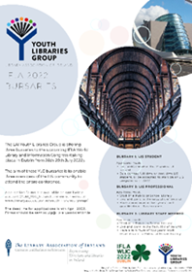

Seed funding for the School Library Group (SLG)
The YLG committee will support the newly established LAI group, the SLG with some seed funding for a new website, branding and their inaugural conference costs.

Annual Seminar 2021 & Covid
Due to the Covid-19 pandemic, an in-person conference was again not possible. Our Recommending with Confidence series was online again in early 2021.

Recommending with Confidence
A five-week programme of talks took place January-February 2022 with topics such as bibliotherapy for children, supporting LGBTQI+ youth, fighting words, book clubs and encouraging a reading culture. All lectures were accompanied by a presentation of library projects which applied the principals of the selected topics. All these topics are very relevant to the provision of library services to children and young people and are aligned with current and future funding programmes.

We were overwhelmed by the response, considering that public libraries had re-opened, with an average of 147 participants booked into the series every week. There were 381 unique attendees across the 5-week series.

Bibliotherapy for Children with Elaina Ryan, CEO of Children’s Books Ireland
Children’s Book Ireland did an incredible job on their recommended reading guides entitled “Mind Yourself” and “Free to be me”. Both feature an extensive range of books dealing with issues facing children and young adults. Elaina will talk about the reading guides and how library staff can use them in their own locations.
Project: “Book Magic” presented by Darina Molloy Mayo Libraries

Supporting LGBTQI+ Youth with Collette O'Regan from LGBT Ireland
This is an awareness session looking at topics such the terminology used around the community, common issues that arise for young LGBTQI+ people, how we could support them within our libraries and an overview of services available that we can direct young people to.
Project: 'Rainbow Bag' presented by Karen McCague Monaghan

Fighting Words
'Fighting Words' was first established in 2009 by Roddy Doyle and Séan Lowe. The vision of Fighting Words is simple – to give children and young people the opportunity to discover and harness the power of their own imaginations and creative writing skills.
Project: “Fighting Words programme” presented by Mila Taylor DLR Libraries.

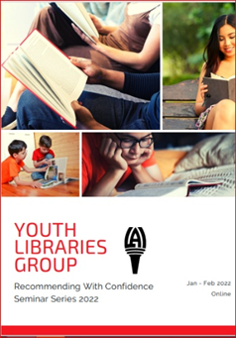

Book Clubs for Children & Young People
This is an evidence-based, dialogic story-reading project that aims to support parents in reading stories to their children in order to develop children’s oral language. This one-hour seminar for librarians shares a description of how the project works and includes story time tip-sheets, book lists and oral language strategies for parents.

Encouraging a reading culture - Scottish Book Trust with Rachael Laburn and Maggie Still
This webinar will take library staff through practical tips and tools for engaging children with books and encouraging participation, including how to build your confidence and run a class visit in your setting. The session will also include examples of best practice from libraries in Scotland and showcase reading recommendations for 8 to 12 year-olds that engage both reluctant and keen readers.

Acknowledgements

The LAI acknowledges with thanks the support of the many organisations, institutions and individuals without whose cooperation and support the Association could not have functioned this year and every year.
Particular thanks are due to the following:
Dublin City Public Libraries for providing a correspondence address and for making available facilities for meetings.
The very many other library organisations that accommodated committee meetings, CPD events and activities throughout the year.
The Heads of Library Services and other leaders who have facilitated staff to act as Officers of the Association and engage on Council, Committees, Groups and Sections.
The Royal Irish Academy, Dublin City Public Libraries, Fingal Libraries, South Dublin County Libraries and Waterford City and County Council Libraries for providing storage for Association records.
The library business sector and other friends of the Association that support its
work through sponsorship of meetings, seminars and other activities

Appendices

Appendix 1 – Organisation of the Association

The Library Association of Ireland (LAI) is a company limited by guarantee. Every member of the Association is a shareholder. The Council acts as the company Board of Directors.
The Constitution establishes the methods and capacity of the Association to manage its business. These are the foundation documents for all action by the Association and they outline procedures in place.
Membership of the Association is open to individuals and institutions. Participative membership is encouraged in order to benefit both the profession and the individual.
The annual report illustrates the range of opportunities for active participation that are open to members currently. The Articles of Association describe the procedure to initiate other relevant activity. Activities can be at individual
and group levels. Activity at individual level can include research, writing, mentoring, training, further education, advocacy or contributing a specialist expertise. Group work can include all of the above in community with others. Membership of Groups and Sections is a benefit of LAI membership. In particular, participation at Committee level in a Group or Section can be a valuable learning and networking experience.
Committees are elected at the Annual General Meetings of each Group and Section. The election process is advertised to members in advance. Groups and Sections have documented procedures which operate within the parameters of the overarching Memorandum and Articles of the Association, sometimes with refinements to suit local circumstances. For example, groups and sections can create time-specific, focused sub-committees or working groups in response to their own priorities.
If you wish to join a group or section, select it when joining or renewing your Association membership.
If you are interested in joining the committee of a group or section, please contact its chair or secretary.

Membership of the LAI Council and election to the offices of President, Vice-President, Honorary Secretary and Honorary Treasurer is open to all personal members in good standing. The procedures are outlined in the Memorandum and Articles.

The Council has a range of committees and may form panels or taskforces to address topical issues. In general, panels and taskforces are of a temporary nature and their membership may include individuals who are not members of Council.

The Association sometimes provides nominees to a range of external organisations. These are listed in the annual report. The selection of nominees varies depending upon the organisation involved

Appendix 2 - Committees

Management and Administration
• Council
• Management Committee

Developing the Profession
• Education Committee: Professional Standards
• Education Committee: Continuing Professional Development
• Library Ireland Week Taskforce
• Literacies Committee

Communications
• Website Development and Social Media
• Editorial Board of An Leabharlann: The Irish Library

Supporting Co-operation Between Libraries and Library
Organisations
• North/South Liaison [with CILIP Ireland]
• Annual Joint Conference Committee [with CILIP Ireland]

Groups and Sections
Sectoral
• Academic and Special Libraries Section
• County and City Librarians Section
• Government Libraries Section
• Public Libraries Section

Regional
• Western Regional Section

Special Interest [Cross-Sectoral]
• Career Development Group
• Cataloguing and Metadata Group
• Genealogy and Local Studies Group
• Health Services Libraries Group
• Library Publishing Group
• Open Scholarship Group
• Rare Books Group
• School Libraries Group
• Youth Libraries Group

LAI Council is responsible for the correct and effective running of the Association. Consequently, all committees, groups and sections submit regular reports to the honorary secretary for consideration at Council meetings.

Appendix 3 – List of Abbreviations

The following abbreviations may be found within the text of the report.
General
AGM – Annual General Meeting
ALAI – Associateship of the Library Association of Ireland CPD – Continuing Professional Development
FLAI – Fellowship of the Library Association of Ireland G&S – Groups and Sections
GDPR – General Data Protection Regulations
ILI – Internet Librarian International Conference
LIS – Library and Information Studies
MLIS – Master of Library and Information Studies SIG – Special Interest Group

Library Association of Ireland Groups and Sections
A&SL – Academic and Special Libraries Section
CCLS – County and City Librarians’ Section
CDG – Career Development Group
CMG – Cataloguing and Metadata Group
GenLoc – Genealogy and Local Studies Group
GLS – Government Libraries Section
HSLG – Health Sciences Libraries Group
MRS – Munster Regional Section
PLS – Public Libraries Section RBG – Rare Books Group
WRSLAI – Western Regional Section
YLG – Youth Libraries Group

Other abbreviations
AMNCH – Adelaide, Meath, and National Children’s Hospital
ANLTC – Academic and National Library Training Co-operative
ARLIS – Art Libraries Society
Athlone IT – Athlone Institute of Technology
BIALL – The British and Irish Association of Law Librarians
CCT – CCT College, Dublin
CDETB – City of Dublin Education and Training Board
CILIP – Chartered Institute of Library and Information Professionals
CONUL – Consortium of National and University Libraries
CRANN – Centre for the Research on Adaptive Nanostructures and Nanodevices)
CSSO – Chief State Solicitor’s Office
CUAL – Connacht Ulster Alliance Libraries
DBS – Dublin Business School
DCPL – Dublin City Public Libraries
DPER – Department of Public Expenditure and Reform
DCU – Dublin City University
DIAS – Dublin Institute of Advanced Studies
DIT – Dublin Institute of Technology
DLR – Dún-Laoghaire Rathdown
DPP – Director of Public Prosecutions
EBLIDA – European Bureau of Library Information and Documentation
Associations
ETBI – Education and Training Boards Ireland
GMIT – Galway Mayo Institute of Technology
HRB – Health Research Board
HSE – Health Services Executive
IADT – Institute of Art, Design and Technology
IBAT – IBAT College, Dublin
IFLA – International Federation of Library Associations and Institutions
IMI – Irish Management Institute
IT Carlow – Institute of Technology Carlow
ITT – Institute of Technology Tallaght
JCSP – Junior Cycle Social inclusion Programme
L2L – Library Staff Learning to Support Learners Learning (NF Project)
LAI – Library Association of Ireland
LISC – Library and Information Services Council
LGMA – Local Government Management Agency
LIR – HEANet User Group for Libraries
LYIT – Letterkenny Institute of Technology
MIE – Marino Institute of Education
MLI – Media Literacy Ireland
MTU – Munster Technology University
MU – Maynooth University
NCAD – National College of Art and Design
NCEC – National Clinical Effectiveness Committee
NCI – National College of Ireland
NF – National Forum for the Enhancement of Teaching and Learning
NLI – National Library of Ireland
NUI – National University of Ireland
PKSB – Professional Knowledge and Skills Base (CILIP UK)
QQI – Quality and Qualifications Ireland
RCPI Royal College of Physicians of Ireland
RCSI – Royal College of Surgeons Ireland
RDS – Royal Dublin Society RIA – Royal Irish Academy
RIA – Royal Irish Academy
SJOG – Saint John of God’s
TCD – Trinity College Dublin
TU Dublin – Technological University Dublin
TUS – Technological University of the Shannon: Midlands Midwest
UCC – University College Cork
UCD – University College Dublin
UCD SICS – University College Dublin, School of Information & Communication Studies
UL – University of Limerick
WIT – Waterford Institute of Technology
WLIC – World Library and Information Congress

